Enterprise Active Directory, Perimeter Security & Remote Access Lab
A Comprehensive Technical Architecture, Deployment & Hardening Field Guide
Project Lead: Ayomide (@Ayomide) | Date: October - November 2026 | Environment: Windows Server 2025, pfSense 2.7.2, Active Directory DS

Executive Summary & Architecture Overview
This project documents the end-to-end design, implementation, verification, and hardening of an enterprise-grade hybrid infrastructure lab. Beginning with a single Windows Server 2025 Domain Controller (lab.local) managing Active Directory Domain Services (AD DS), DNS, and local mail routing, the environment evolved into a segmented multi-site enterprise network secured by redundant pfSense firewalls, centralized RADIUS/NPS authentication, enterprise IKEv2 IPsec VPN, and modern Zero-Trust Tailscale mesh overlay routing.
Every phase of this documentation reflects real, verified engineering workflows executed across virtualized hypervisors. Crucially, it captures real-world failure states, edge-case gotchas (such as dual-homed DNS hijacking, IKEv2 SAN certificate requirements, and GPO UNC path resolution), packet-level captures, and step-by-step diagnostic methodologies required to build, break, and successfully operate production IT infrastructure.

Master Environment Specifications & Addressing Matrix
The complete environment integrates multiple subnets, security boundaries, and AAA components as detailed below:
Component / Node | Operating System / Role | Interface / Subnet | IP Address | Gateway / DNS Target
DC01 (Server) | Windows Server 2025 Std (AD DS, DNS, NPS) | LAN (HQ) | 192.168.10.10/24 | GW: 192.168.10.1 | DNS: 127.0.0.1
PC01 (Client) | Windows 11 Enterprise (Domain Joined) | LAN (HQ) | 192.168.10.20/24 | GW: 192.168.10.1 | DNS: 192.168.10.10
FW-HQ (Firewall) | pfSense CE 2.7.2 / FreeBSD 16.0 | em1 (LAN)  em0 (WAN) | 192.168.10.1/24  192.168.23.138/24 | WAN GW: 192.168.23.2  DNS Forwarder enabled
FW-Branch (Firewall) | pfSense CE 2.7.2 / FreeBSD 16.0 | em1 (LAN)  em0 (WAN) | 192.168.20.1/24  192.168.23.139/24 | WAN GW: 192.168.23.2  DNS Forwarder enabled
Branch Client | Windows 11 Client (Branch Site) | LAN (Branch) | 192.168.20.x/24 | GW: 192.168.20.1 | DNS: pfSense / DC01
Simulated WAN Transit | Hypervisor Virtual Switch / Bridge | Transit Subnet | 192.168.23.0/24 | Upstream NAT GW: 192.168.23.2
IPsec Mobile Clients | Remote Dial-In Pool (IKEv2 EAP-RADIUS) | Virtual Tunnel Pool | 10.10.100.0/24 | Encapsulated across WAN to HQ LAN
Tailscale Mesh Overlay | WireGuard Subnet Router (pfSense) | Overlay CGNAT Subnet | 100.115.4.8 (FW)  100.106.74.113 (Ext PC) | Advertises route: 192.168.10.0/24

Chapter 1 — Foundation: Windows Server 2025, Active Directory & Mail Services
The foundational phase focuses on provisioning the core Windows Server 2025 Domain Controller (DC01) for the lab.local domain. To establish a realistic testing ground, the DC hosts Active Directory Domain Services, internal DNS, and a standalone mail server (hMailServer). This configuration creates an immediate end-to-end feedback loop: validating that identity, DNS resolution, and application transport cohesively function between server and client.
[ENTERPRISE ARCHITECTURE NOTE] In production environments, running messaging services (SMTP/IMAP) directly on an Active Directory Domain Controller violates the principle of least privilege and attack surface minimization. A domain controller should exclusively govern identity and authentication. This co-location is intentional here solely to establish a compact, multi-service lab testing baseline on constrained hardware.

Part 0 & 1 — Static IP Addressing & Network Persistence
A Domain Controller must possess an unyielding, predictable IP address. If a Domain Controller were to acquire dynamic DHCP addresses, DNS records would silently drift, causing Active Directory authentication, Kerberos ticket issuance, and GPO replication to collapse across all domain members.
On DC01, PowerShell is utilized to verify that the IPv4 address is manually assigned rather than dynamically leased via DHCP:
Get-NetIPAddress -AddressFamily IPv4 | Where-Object {$_.IPAddress -notlike '169.*' -and $_.IPAddress -ne '127.0.0.1'} | Select-Object IPAddress, PrefixOrigin

A PrefixOrigin of 'Manual' confirms a static assignment, whereas 'Dhcp' indicates dynamic configuration that must be corrected.
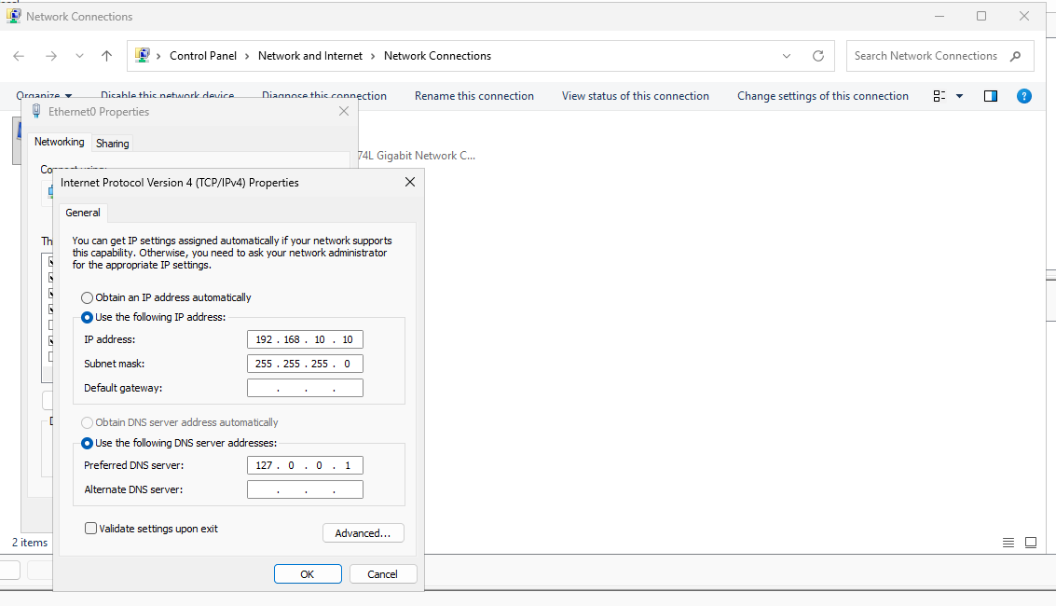
Figure 1: DC01 Network Adapter Configuration — Static assignment of IPv4 192.168.10.10/24 with loopback DNS (127.0.0.1) pointing directly to its local DNS service.

Part 2 — Active Directory DNS Architecture for Mail Delivery
Email routing relies on a two-step DNS resolution mechanism. Mail Transfer Agents (MTAs) first query the Mail Exchanger (MX) record to discover the canonical host responsible for incoming mail for the target domain (@lab.local), followed by a Host (A) lookup to resolve that host to an IP address.
Implementation Steps: Within DNS Manager (dnsmgmt.msc), inside the Forward Lookup Zone 'lab.local', two fundamental records are created:
- Host (A) Record: Name: 'mail', IP Address: 192.168.10.10. Resulting FQDN: mail.lab.local.
- Mail Exchanger (MX) Record: Host / Child Domain: [Blank] (represents @lab.local), FQDN of mail server: mail.lab.local, Priority: 10.
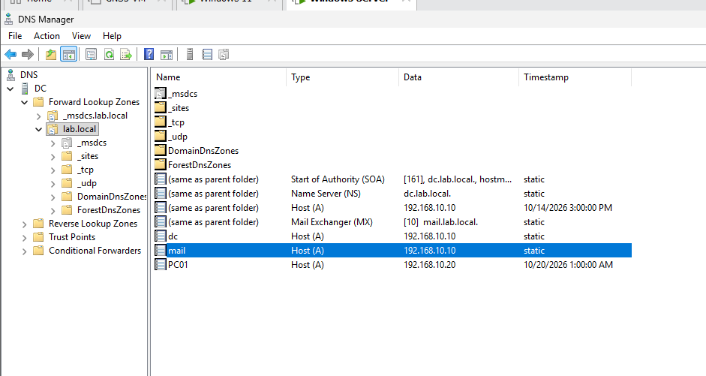
Figure 2: Active Directory DNS Zone Records — The lab.local Forward Lookup Zone displaying the completed Host (A) record (mail -> 192.168.10.10) and MX record (Priority 10).
Validation is performed from the command line using nslookup to verify that records correctly resolve locally and across domain clients:
nslookup -type=mx lab.local
nslookup mail.lab.local

Parts 3, 4 & 5 — hMailServer Engine, Relay Permissions & Port Security
hMailServer is deployed utilizing its embedded Microsoft SQL Server Compact database engine to minimize external dependencies. Crucially, hMailServer enforces an internal software firewall known as 'IP Ranges' (Settings > Advanced > IP Ranges). By default, connections originating outside localhost (127.0.0.1) are dropped. To allow client workstations to communicate, the local subnet (192.168.10.0/24) must be authorized for SMTP, IMAP, and POP3.
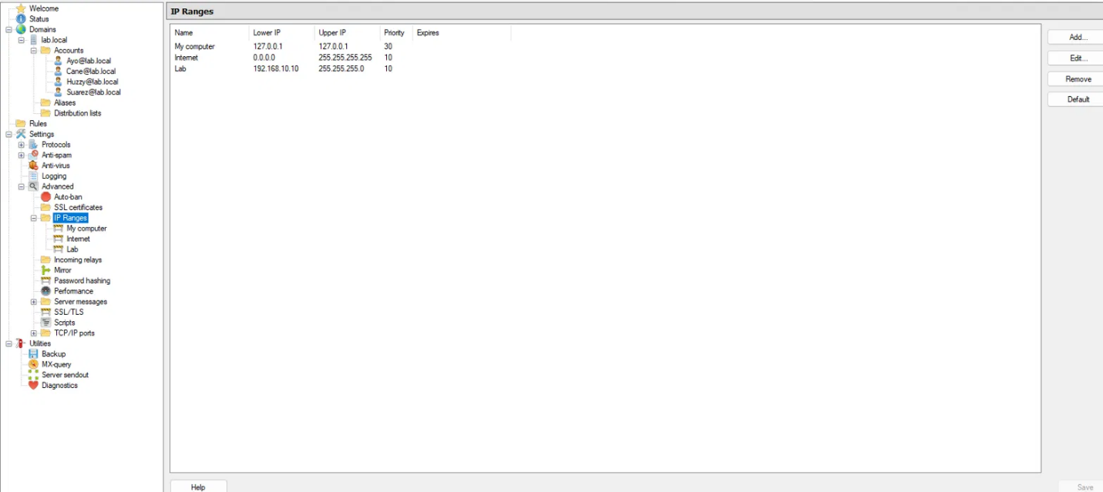
Figure 3: hMailServer Subnet Access Rules — Configuring the 'Lab' IP range (192.168.10.0/24) with SMTP, IMAP, and POP3 delivery rights.
In parallel, Windows Defender Firewall on DC01 must be instructed to permit incoming traffic across these service ports:
New-NetFirewallRule -DisplayName 'Mail SMTP' -Direction Inbound -Protocol TCP -LocalPort 25 -Action Allow
New-NetFirewallRule -DisplayName 'Mail IMAP' -Direction Inbound -Protocol TCP -LocalPort 143 -Action Allow
New-NetFirewallRule -DisplayName 'Mail POP3' -Direction Inbound -Protocol TCP -LocalPort 110 -Action Allow

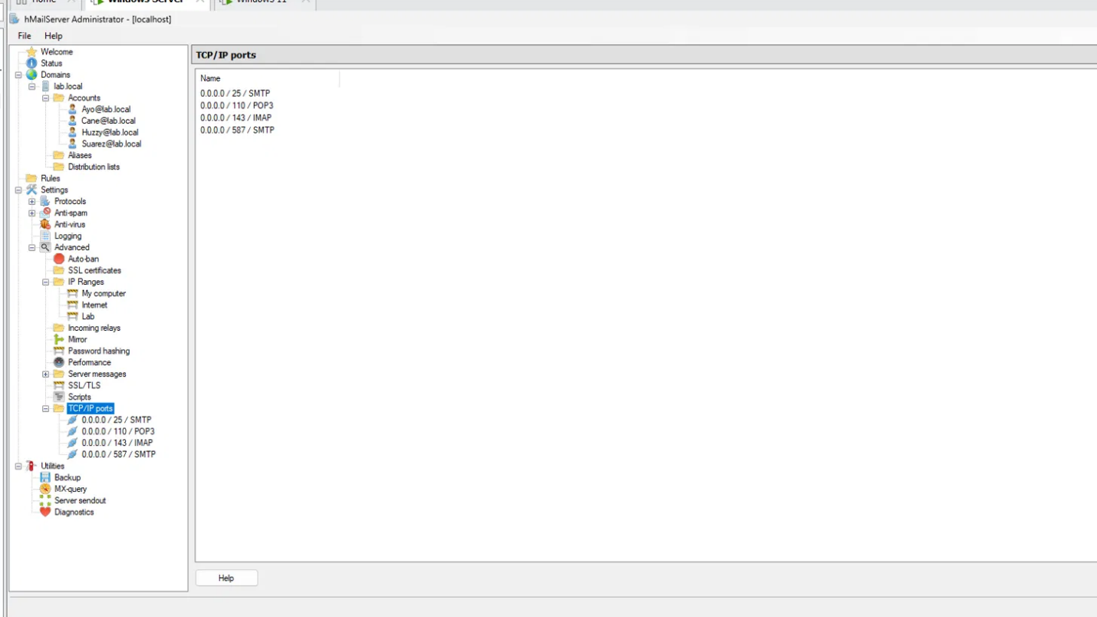
Figure 4: hMailServer Port Bindings & Listener Status — Verification that the daemon is actively listening across TCP ports 25 (SMTP), 110 (POP3), 143 (IMAP), and 587 (Submission).

Part 6 — Client Configuration (eM Client)
On the Windows 11 client workstation, eM Client is installed. Because lab.local is a private, disconnected domain without public Autodiscover records or external SSL certificates, automatic mailbox provisioning will gracefully fail. Manual configuration must be selected.
- Incoming Server (IMAP): mail.lab.local, Port 143, Security Policy: 'Don't use secure connection' / Plain.
- Outgoing Server (SMTP): mail.lab.local, Port 25, Security Policy: 'Don't use secure connection' / Plain.
- Authentication: Full mailbox address (e.g., john@lab.local), not merely the sAMAccountName.
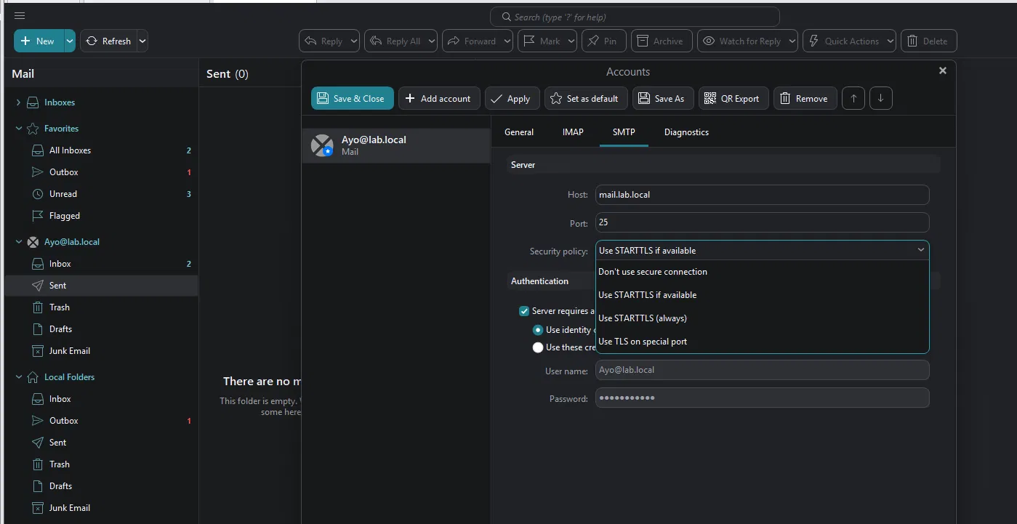
Figure 5: eM Client SMTP Configuration — Manual parameter entry for mail.lab.local on Port 25, explicitly setting security to 'Don't use secure connection' to prevent STARTTLS negotiation failure.

Part 7 — End-to-End Verification & Health Checks
Verification is conducted systematically across transport, socket, and application layers. First, a live email is composed and transmitted between user mailboxes (Cane@lab.local -> Ayo@lab.local):
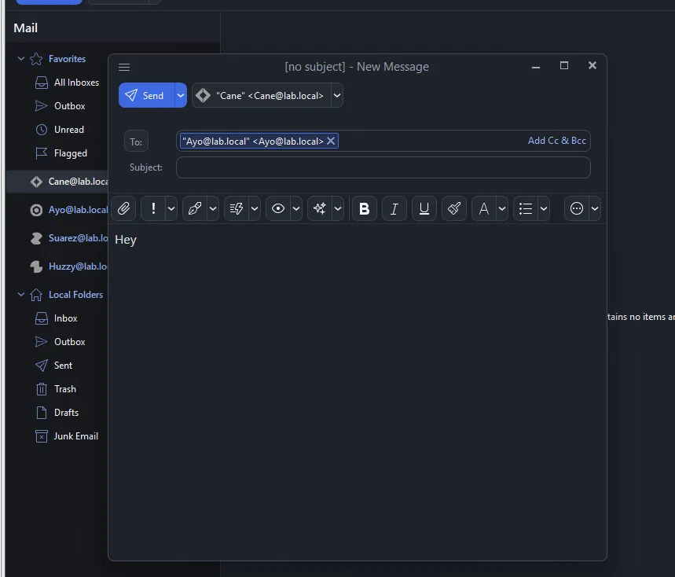
Figure 6: Live Mail Composition & Dispatch — Dispatching test message from Cane@lab.local to Ayo@lab.local, verifying instant queue dispatch and inbox ingestion.
To rule out client software bugs during diagnostics, lower-level PowerShell testing is performed directly against the socket and MTA:
# Test raw socket reachability
Test-NetConnection 192.168.10.10 -Port 25
# Perform automated command-line dispatch
Send-MailMessage -From 'Cane@lab.local' -To 'Ayo@lab.local' -Subject 'PowerShell Test' -Body 'Direct SMTP injection' -SmtpServer '192.168.10.10'

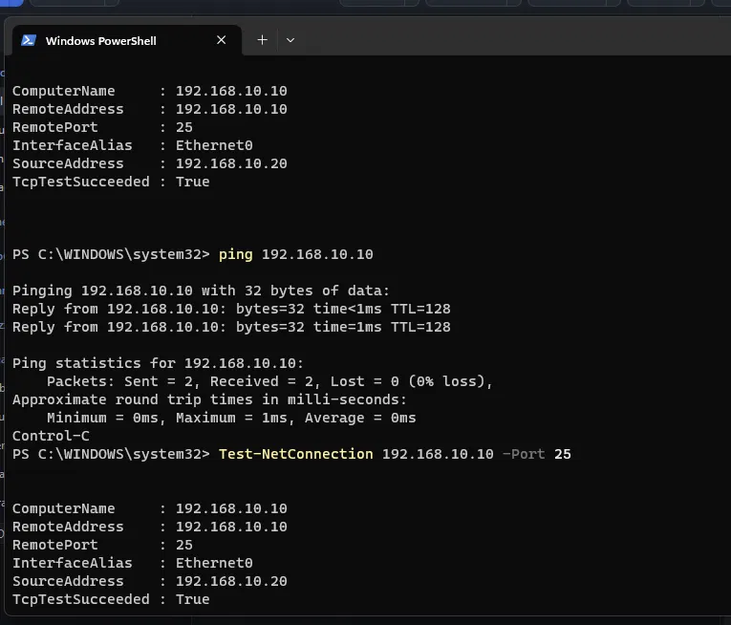
Figure 7: TCP Socket Test (Test-NetConnection) — PowerShell confirms TcpTestSucceeded: True against 192.168.10.10 on Port 25, confirming firewall and daemon binding.
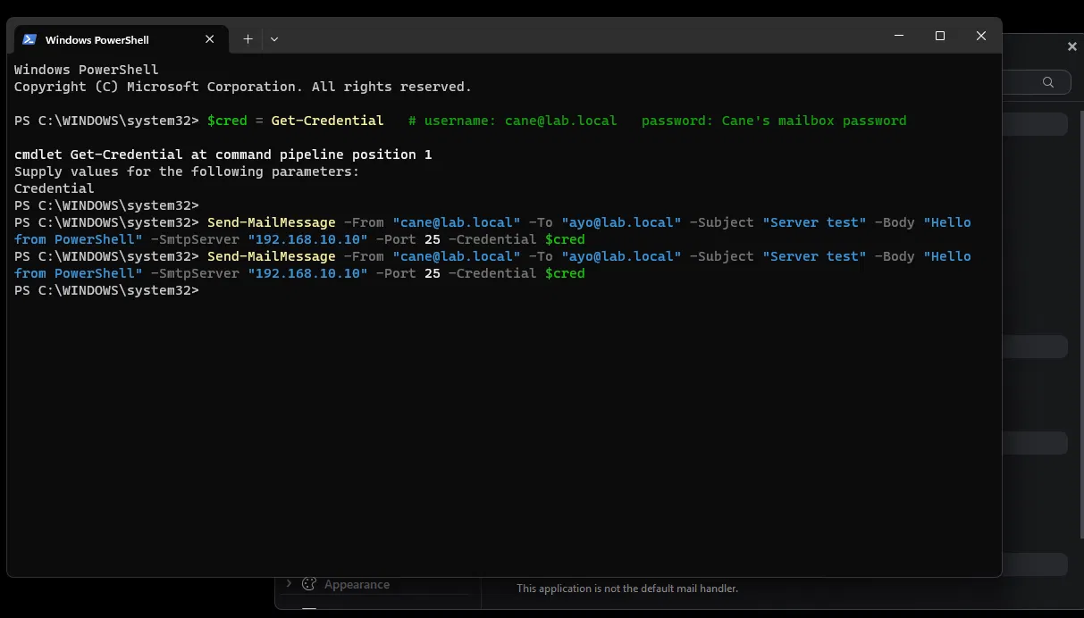
Figure 8: Automated SMTP Dispatch — Send-MailMessage returns cleanly without errors, proving the MTA accepts local delivery independent of GUI mail clients.
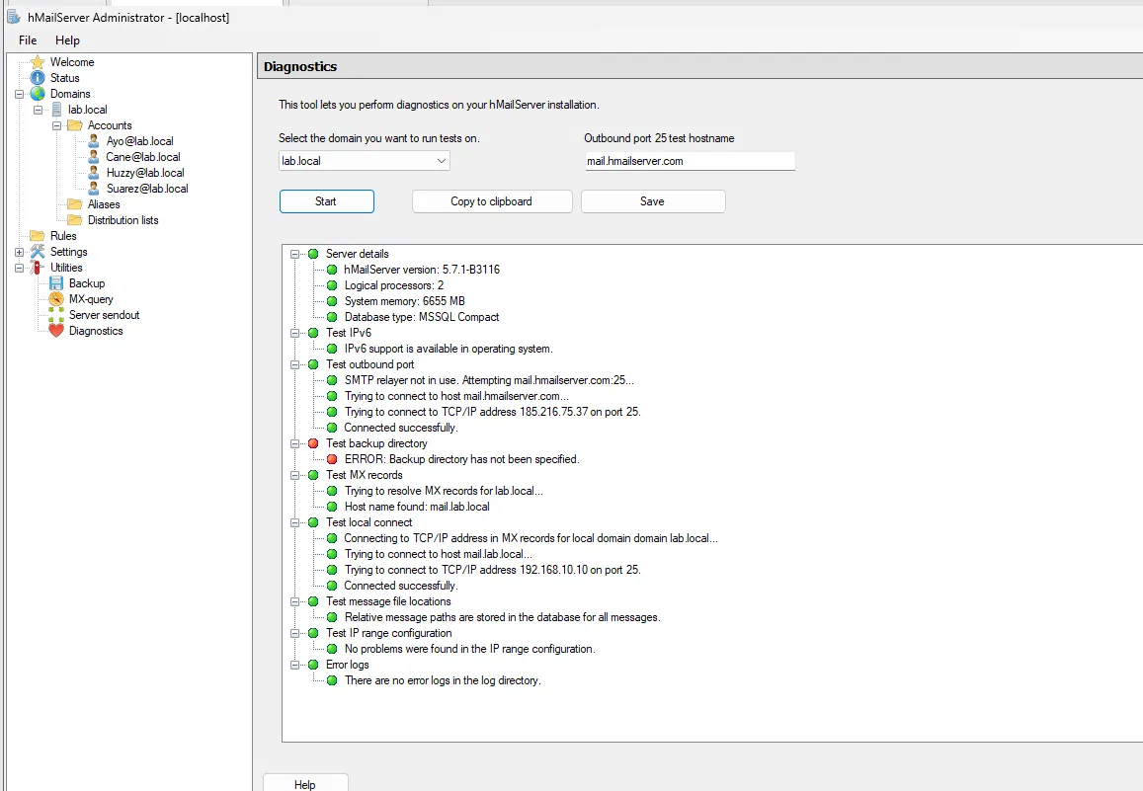
Figure 9: hMailServer Diagnostics Utility — The built-in diagnostic test suite reports all green checks for lab.local MX resolution, IPv4 connectivity, and port binding.

Part 8 — Troubleshooting & The Dual-Homing DNS Hijacking Trap
During lab testing, a subtle but catastrophic failure state frequently emerges when virtual machines are assigned two network adapters: one on the isolated internal network (LAN Segment) and one on NAT (to download packages from the internet). This dual-homed condition causes sudden, mysterious domain logons and mail failures.
[THE DUAL-HOMING DNS TRAP EXPLAINED] When Windows has two active network adapters, the adapter that receives a Default Gateway (typically the DHCP-managed NAT adapter) is treated by the Windows TCP/IP stack as the primary interface. Windows automatically routes all outbound DNS queries to the NAT adapter's DNS server! Because the NAT router knows nothing about 'lab.local', domain lookups fail silently, and mail remains stuck in the Outbox.

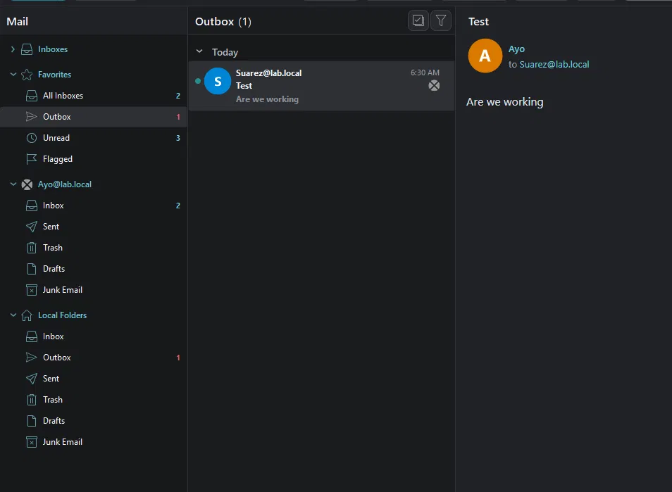
Figure 10: The Symptom: Message Trapped in Outbox — Mail languishing indefinitely in Local Folders > Outbox due to unresolved SMTP transport addresses.
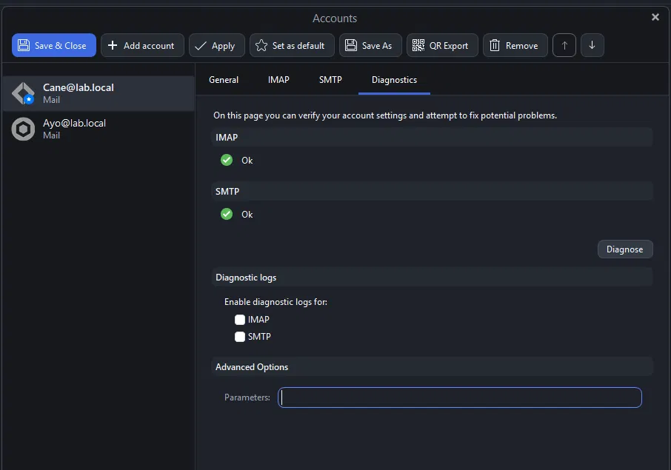
Figure 11: Healthy Account State Post-Remediation — Account diagnostics indicating operational IMAP and SMTP connections once DNS routing is restored.
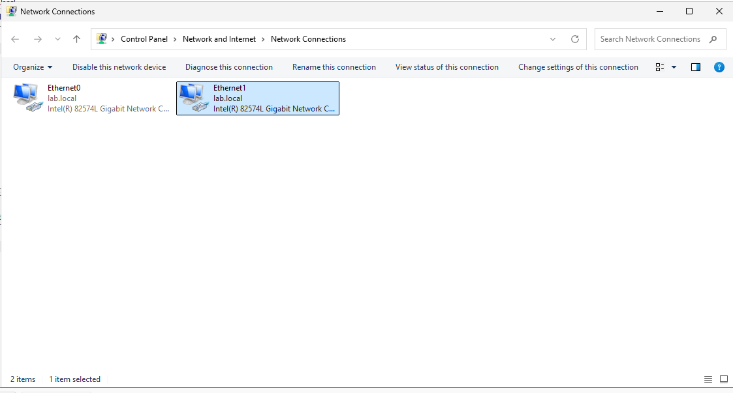
Figure 12: Dual-Homed Network Adapters in Windows — Ethernet0 (Internal LAN) and Ethernet1 (NAT) simultaneously bound to the machine, competing for route precedence.
The exact symptom can be demonstrated by executing nslookup lab.local: the query returns two conflicting IP addresses—the genuine DC (192.168.10.10) and the rogue NAT IP (192.168.23.133) that was automatically registered into DNS:
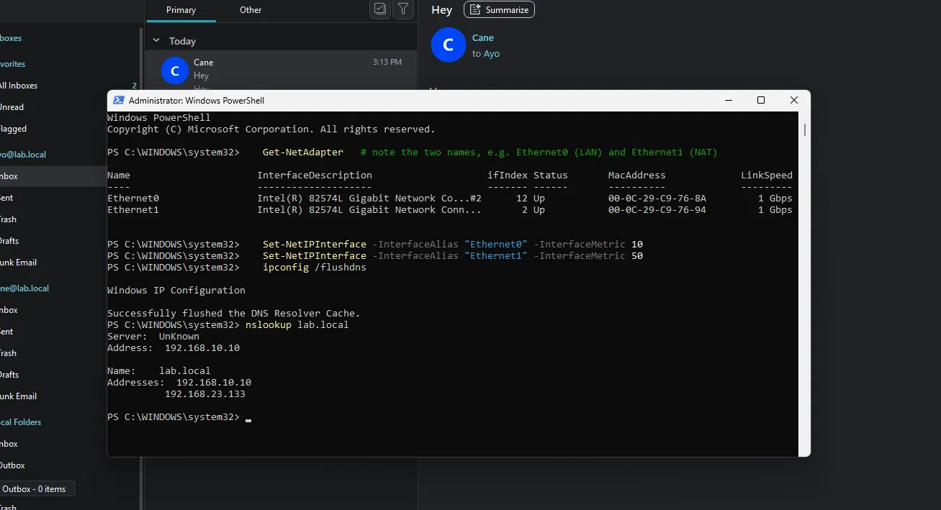
Figure 13: DNS Pollution & Split Resolution — nslookup returning both 192.168.10.10 and 192.168.23.133, causing random intermittent connection timeouts.
Remediation Protocol: The permanent resolution is twofold: First, force Windows to prioritize the internal LAN adapter using interface metrics. Second, disable automatic dynamic DNS registration on the secondary adapter:
# Enforce adapter priority: lower metric = higher priority
Set-NetIPInterface -InterfaceAlias 'Ethernet0' -InterfaceMetric 10 # Internal LAN
Set-NetIPInterface -InterfaceAlias 'Ethernet1' -InterfaceMetric 50 # NAT Adapter
# Flush stale resolver cache
ipconfig /flushdns

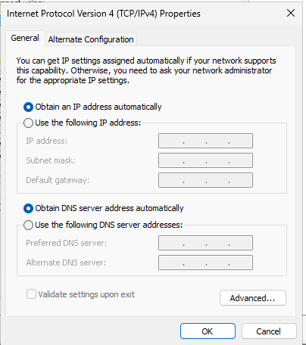
Figure 14: Disabling Dynamic DNS Registration on NAT Adapter — Navigating to Advanced TCP/IP Settings > DNS tab and unchecking 'Register this connection's addresses in DNS' to prevent zone poisoning.

Chapter 2 — Active Directory Administration, Permissions & Group Policy
Active Directory serves as the enterprise source of truth for identity, authorization, and endpoint configuration. Chapter 2 builds a hardened enterprise environment incorporating structured Organizational Units (OUs), the industry-standard AGDLP group scoping model, granular file sharing (NTFS vs Share permissions), Group Policy Preferences drive mapping, and computer-level baseline lockdown.

Section 1 — The AGDLP Methodology & Group Scoping
In enterprise administration, permissions must never be granted directly to individual user accounts. Direct assignments result in 'permission sprawl', untraceable privileges, and severe security debt. Instead, Microsoft recommends the AGDLP framework:
- A (Account): The human identity (e.g., Ayo, Huzzy, Suarez).
- G (Global Group): Represents job function or role (e.g., GG_Accounting, GG_Banking, GG_IT). Scope: Global. Lives in user's domain.
- DL (Domain Local Group): Represents permission intent on a specific resource (e.g., DL_AccountingModifier, DL_Banking). Scope: Domain Local.
- P (Permission): The actual Access Control Entry (ACE) applied to the Access Control List (ACL) of the target file share or service.
The group scope rules are architecturally enforced by Active Directory: Global groups can be nested inside Domain Local groups, but Domain Local groups cannot be nested inside Global groups. This guarantees that user management (Global) remains strictly decoupled from resource management (Domain Local).

Section 2 — File Server Security: NTFS vs Share Permissions
When securing Windows network file shares, administrators confront two distinct permission layers. Understanding their interplay is essential to preventing data leaks:
- Share Permissions: Acts as the outer gate. Only applies to network traffic (UNC paths). Has no effect on local console access. Offers coarse permissions (Read, Change, Full Control).
- NTFS Permissions: Acts as the vault door. Encoded directly into the NTFS file system metadata. Applies universally over the network AND locally at the console. Highly granular.
[SECURITY PRINCIPLE: MOST RESTRICTIVE APPLIES] Rule of Access Resolution: When accessing a file over the network, Windows evaluates BOTH Share permissions and NTFS permissions, and enforces the MOST RESTRICTIVE result. If Share is 'Read' and NTFS is 'Full Control', the effective access is Read. Best Practice: Configure Share permissions broadly (e.g., Authenticated Users = Change) and execute ALL security locking exclusively in NTFS.

Section 3 — File Server Build & Permission Hardening
Two departmental shares were provisioned on DC01: C:\Shares\Accounting and C:\Shares\Banking. Hardening these shares requires dismantling the dangerous default permissions inherited from the drive root:
- 1. The Default Inheritance Leak: By default, a new folder inherits 'Users' (LAB\Users, representing ALL domain users) with Read & Execute permissions. Until removed, any user can read confidential files!
- 2. Breaking Inheritance: Advanced Security Settings > Disable inheritance > 'Convert inherited permissions into explicit permissions on this object'.
- 3. Purging Unauthorized Access: Remove all 'Users' entries. Retain SYSTEM, Administrators, and CREATOR OWNER.
- 4. Granting Role Permission: Add the matching Domain Local group (e.g., DL_Banking) and grant 'Modify' (Read, Write, Execute, Delete). Never grant 'Full Control' to ordinary users, as Full Control allows them to modify ownership and ACLs!
- 5. Nested Private Subfolder Proof: Inside C:\Shares\Banking, a subfolder 'HR_PRIVATE' was created. Inheritance was broken, DL_Banking was stripped, and access was granted solely to 'HR_Private'. When tested using the 'Effective Access' tab, members of DL_Banking receive explicit red crosses—proving subfolder isolation.

Section 4 — Automated Drive Mapping via Group Policy Preferences
Rather than relying on legacy batch logon scripts ('net use B: \\DC\Accounting'), modern environments deploy Group Policy Preferences (GPP). GPP enables centralized drive mapping coupled with Item-Level Targeting (ILT):
- Accounting Drive: Action: Update | Location: \\DC01\Accounting | Drive Letter: B: | Label: Accounting Share.
- Targeting Rule: Common tab > Item-level targeting > Security Group: LAB\GG_Accounting.
- Banking Drive: Action: Update | Location: \\DC01\Banking | Drive Letter: K: | Label: Banking Share.
- Targeting Rule: Common tab > Item-level targeting > Security Group: LAB\GG_Banking.
When user Ayo logs in, she receives drive B: and cannot see K:. When Huzzy logs in, he receives drive K: and cannot see B:. The drive maps dynamically evaluate group membership at logon.

Section 5 — Workstation Baseline Security GPO
All client workstations are relocated from the default 'Computers' container (which does not support direct GPO linking) into a dedicated 'OU=Workstations'. A baseline security policy ('Workstations Baseline') is linked, enforcing Computer Configuration settings:
- Inactivity Screen Lock: Security Settings > Local Policies > Security Options > Machine inactivity limit: 900 seconds (15 minutes).
- Legal Warning Banner: Security Settings > Security Options > Message title: 'Authorized Users Only', Message text: 'Corporate legal warning notice'.
- Firewall Lockdown: Windows Defender Firewall with Advanced Security > Domain, Private, and Public profiles set to On; Inbound: Block default.
- USB Mass Storage Ban: Administrative Templates > System > Removable Storage Access > All Removable Storage classes: Deny all access = Enabled.

Section 6 — Centralized Wallpaper & The UNC Path Gotcha
Centrally enforcing corporate desktop wallpaper via Group Policy (User Configuration > Administrative Templates > Desktop > Desktop Wallpaper) frequently triggers a classic sysadmin error.
[THE CRITICAL UNC PATH RESOLUTION RULE] The Local Path Trap: If the GPO references a local path such as 'C:\Wallpaper\Team.jpg', the policy appears valid on the DC where that file exists. However, when applied to a client workstation, Group Policy searches the client's local C: drive! Finding nothing, Windows displays a blank/black desktop without error. Resolution: The image must be placed in a network share (\\DC01\Wallpaper\Team.jpg) accessible by Authenticated Users (Read).

Section 7 — Enterprise Web Browsing Restrictions via Edge Policy Templates
To enforce corporate browsing governance, an allow-list model was implemented for Microsoft Edge. Because Edge ADMX templates do not ship natively inside Windows Server, they must be acquired from Microsoft Edge for Business and seeded into the domain Central Store (\\lab.local\SYSVOL\lab.local\Policies\PolicyDefinitions).
Policy Rules Enforced: Within the policy, two rules govern access (where the allow-list strictly overrides the block-list):
- 1. Global Block: Administrative Templates > Microsoft Edge > Block access to a list of URLs (URLBlocklist) = Enabled, Value: *
- 2. Selective Allow: Administrative Templates > Microsoft Edge > Define a list of allowed URLs (URLAllowlist) = Enabled, Values: microsoft.com, bing.com, lab.local, edge://*
Upon running gpupdate /force on PC01, opening unauthorized sites (e.g., youtube.com) yields an immediate browser block page: 'This page is blocked — your organization doesn't allow you to view this site', confirming enterprise policy compliance.

Chapter 3 — Enterprise Perimeter Security & Multi-Site Networking with pfSense
While a single isolated network provides a suitable sandbox for basic identity testing, modern enterprise environments never operate as flat networks. In enterprise architecture, servers, user workstations, branch offices, and external networks are strictly segregated into dedicated security zones separated by stateful Next-Generation Firewalls (NGFW) or security gateways. Chapter 3 documents the architectural transition from a flat lab to a segmented multi-site enterprise network powered by pfSense.

Section 1 — Architectural Evolution: From Flat Lab to Multi-Site Topology
Multi-Site Network Segmentation: The infrastructure was re-engineered into two distinct geographic sites interconnected across a simulated WAN transit network:
- Headquarters (HQ Site): Hosts the primary corporate infrastructure (192.168.10.0/24), including DC01 (192.168.10.10) and corporate client PC01 (192.168.10.20). Guarded by FW-HQ, which presents an internal LAN gateway of 192.168.10.1 and an external WAN endpoint of 192.168.23.138.
- Branch Office Site: Represents a remote satellite facility (192.168.20.0/24) housing branch workstations. Guarded by FW-Branch, presenting an internal LAN gateway of 192.168.20.1 and an external WAN endpoint of 192.168.23.139.
- Simulated WAN Transit: A routed virtual transit subnet (192.168.23.0/24) with upstream gateway 192.168.23.2 simulating internet / ISP transport between sites.
[CRITICAL GATEWAY SHIFT] Default Gateway Re-Architecture: In the earlier flat lab, DC01 and PC01 had their default gateways left blank because no routing occurred. With pfSense introduced, both Windows hosts must have their Default Gateway explicitly configured to point to their local pfSense LAN IP (192.168.10.1). pfSense then provides stateful inspection, outbound Network Address Translation (NAT), and inter-VLAN routing.

Section 2 — Deploying FW-HQ & Gateway Re-Addressing
FW-HQ is provisioned as a FreeBSD-based pfSense appliance equipped with two network adapters: em0 bound to the simulated WAN (192.168.23.138/24) and em1 bound to the HQ LAN (192.168.10.1/24). Upon initial boot, the console confirms interface assignments.
Testing connectivity from the pfSense console (Option 7: Ping host) toward the Branch WAN IP (192.168.23.139) initially reveals 100% packet loss. This occurs because pfSense enforces a strict default-deny policy on all incoming WAN traffic—a vital security baseline that requires explicit rules to alter.
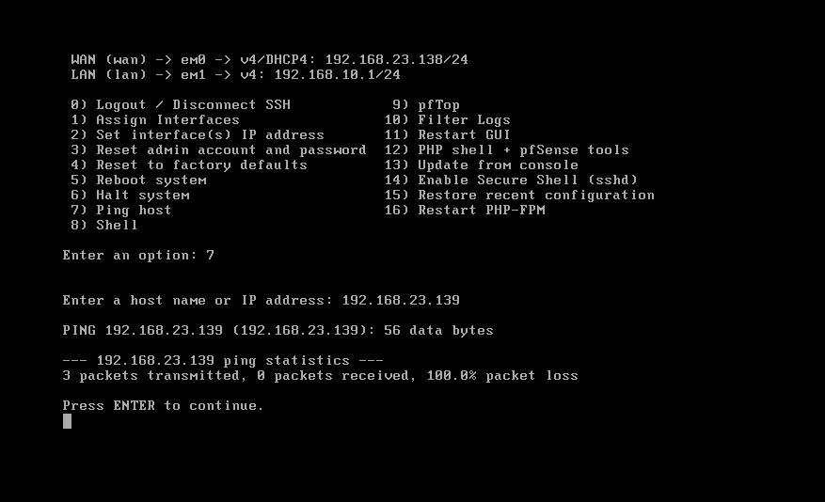
Figure 15: FW-HQ Console & Interface Assignment — Console status displaying WAN (em0: 192.168.23.138/24) and LAN (em1: 192.168.10.1/24). Option 7 ping test to 192.168.23.139 exhibits expected default packet drop.
Next, DC01 is reconfigured to adopt FW-HQ as its default gateway. Within the IPv4 Properties of the network adapter on DC01, the Default Gateway is set to 192.168.10.1, while Preferred DNS remains locked to 127.0.0.1 (local AD DS DNS):
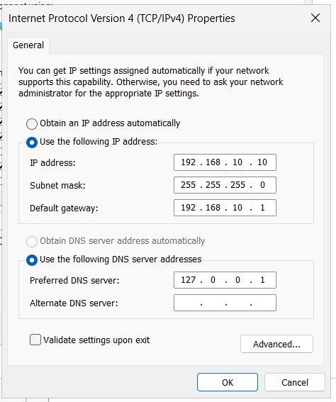
Figure 16: DC01 Default Gateway Configuration — Setting IPv4 Default Gateway to 192.168.10.1 (FW-HQ LAN interface) while maintaining DNS loopback (127.0.0.1) for local Active Directory zone authority.
To confirm that pfSense is actively performing outbound NAT and stateful forwarding, an administrative command prompt on DC01 is used to ping external internet targets (8.8.8.8) and inspect the updated routing configuration:
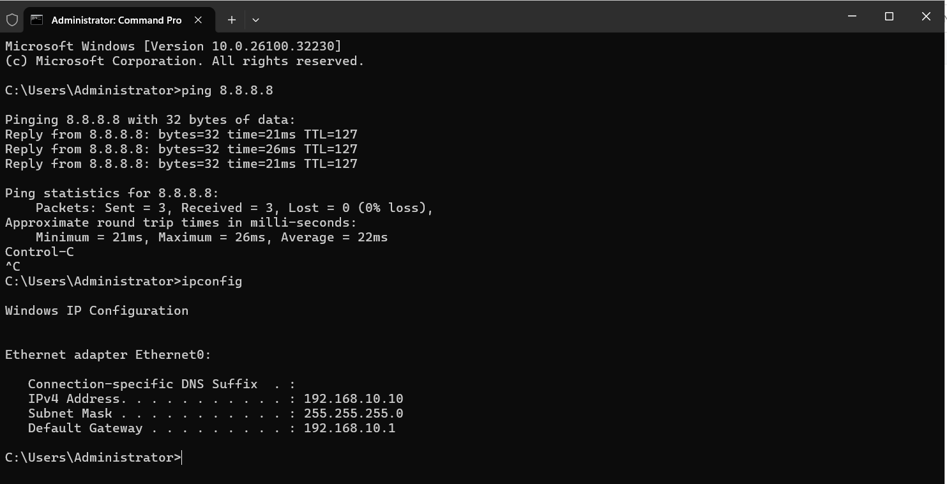
Figure 17: DC01 Internet Reachability Verification — Successful ICMP replies from 8.8.8.8 (21ms-26ms) through pfSense outbound NAT, coupled with ipconfig confirming the active 192.168.10.1 gateway.

Section 3 — Deploying FW-Branch & Branch Client Verification
At the secondary site, FW-Branch is provisioned with matching dual interfaces: em0 mapped to the WAN transit (192.168.23.139/24) and em1 serving the Branch LAN (192.168.20.1/24). The console displays interface binding and provides ping testing:
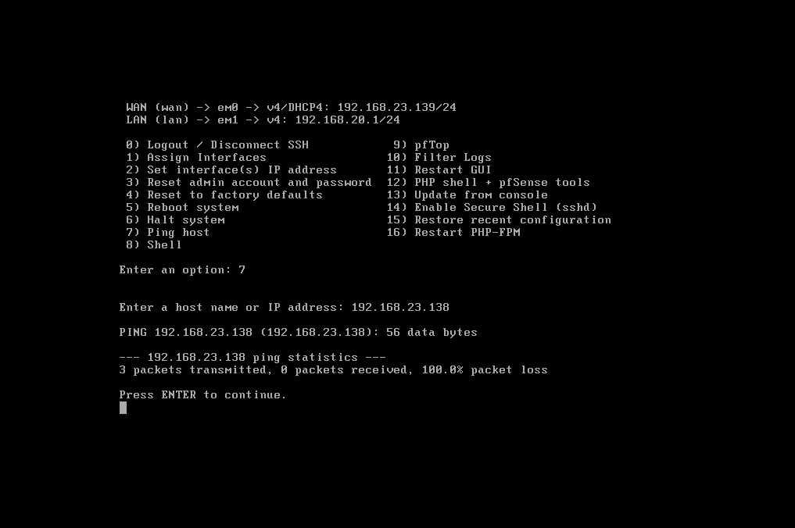
Figure 18: FW-Branch Console Interface Overview — FW-Branch console confirming WAN on em0 (192.168.23.139/24) and LAN on em1 (192.168.20.1/24), with initial diagnostic pinging.
On the HQ Windows 11 client workstation (192.168.10.20), the default gateway is similarly transitioned to 192.168.10.1. Both raw IP reachability (8.8.8.8) and FQDN name resolution (google.com -> 142.251.142.142) are validated, demonstrating that the client successfully resolves names via DC01 DNS forwarders and routes payload traffic through the pfSense firewall:
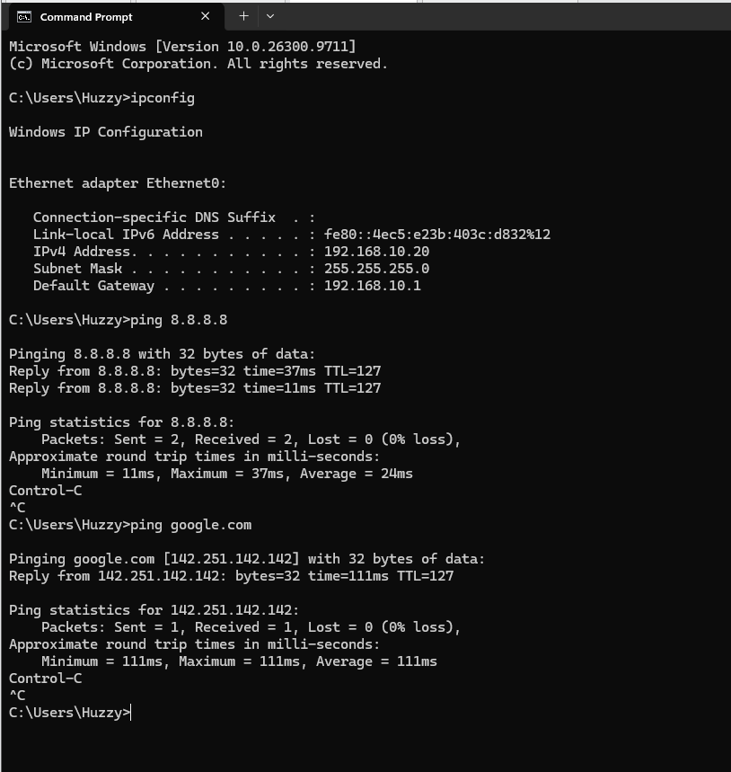
Figure 19: HQ Client Network & Name Resolution Proof — Command prompt on 192.168.10.20 proving zero packet loss to 8.8.8.8 and transparent DNS resolution to google.com over the pfSense gateway.

Section 4 — pfSense WebGUI Management & System Hardening
Management of pfSense is conducted securely via HTTPS through its web interface. Navigating to https://192.168.10.1 from the DC01 browser accesses the pfSense authentication portal:
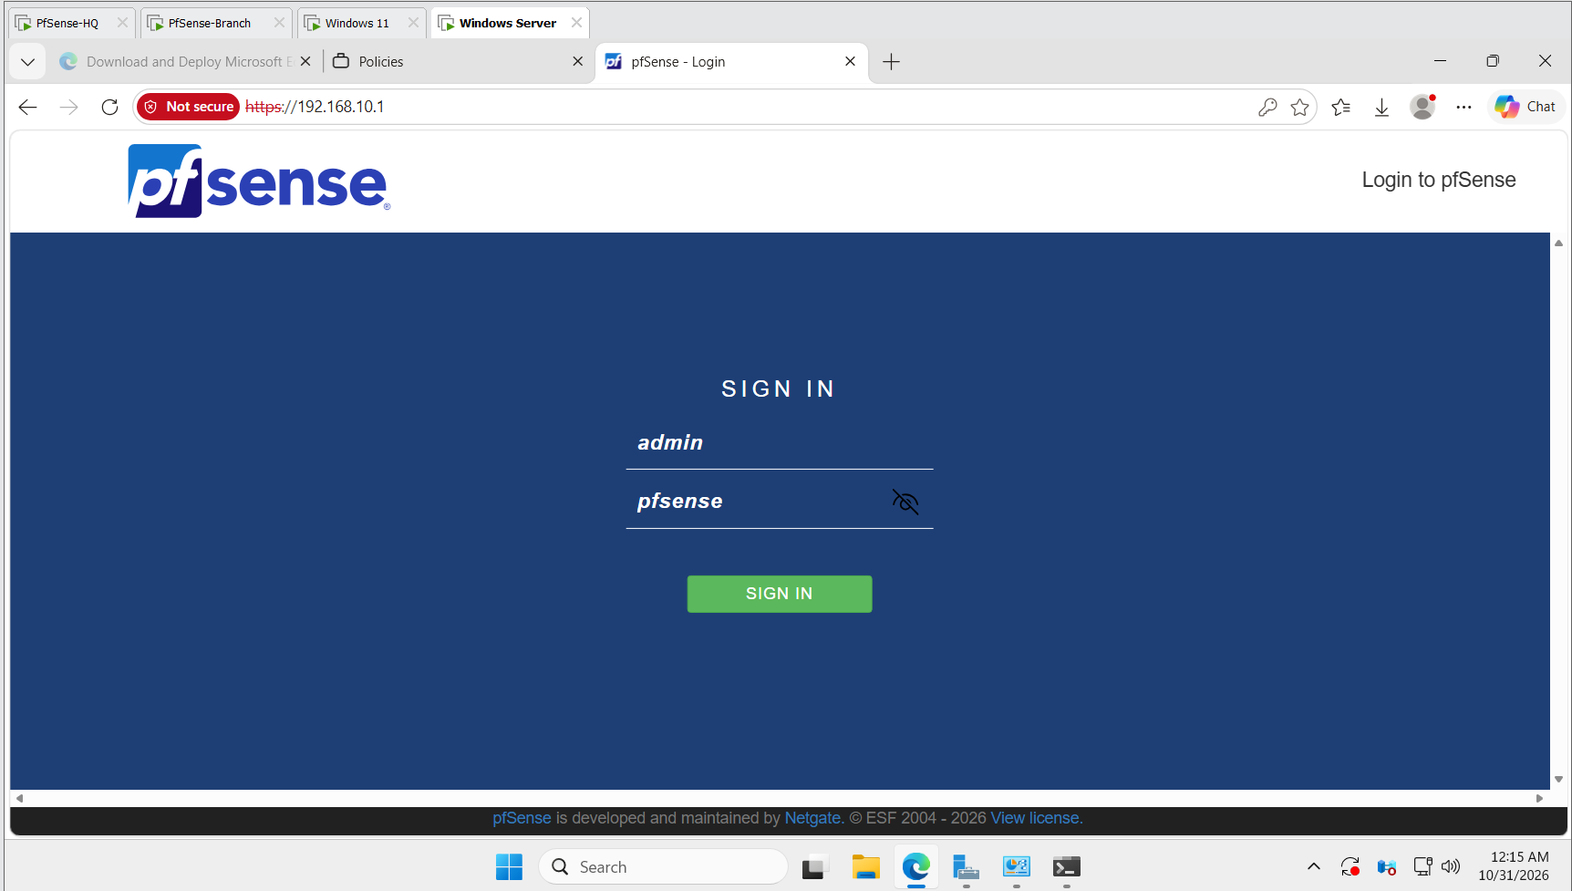
Figure 20: pfSense WebGUI Authentication Portal — Initial web interface sign-in screen on FW-HQ accessed via https://192.168.10.1 using default bootstrap credentials (admin / pfsense).
The pfSense Setup Wizard is executed to initialize system identity. Under General Information, the firewall is assigned Hostname: 'FW-HQ' and Domain: 'lab.local':
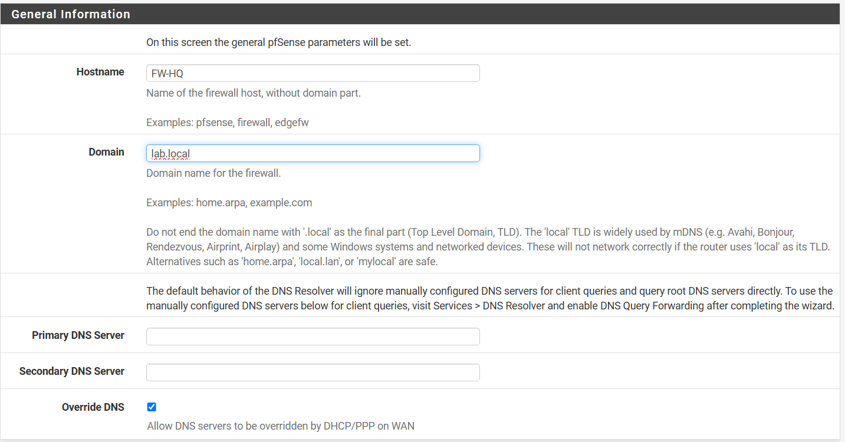
Figure 21: pfSense General Information Setup — Configuring Hostname (FW-HQ) and Domain (lab.local), establishing the device's Fully Qualified Domain Name (FW-HQ.lab.local).
Upon completing the initial wizard, the pfSense System Dashboard displays vital environmental telemetry: the appliance runs pfSense Community Edition 2.7.2 / 2.9.0-RELEASE atop FreeBSD 16.0, powered by an AMD Ryzen 5 PRO 2500U processor with active AES-NI cryptographic instruction acceleration (critical for high-throughput IPsec tunnel encryption):
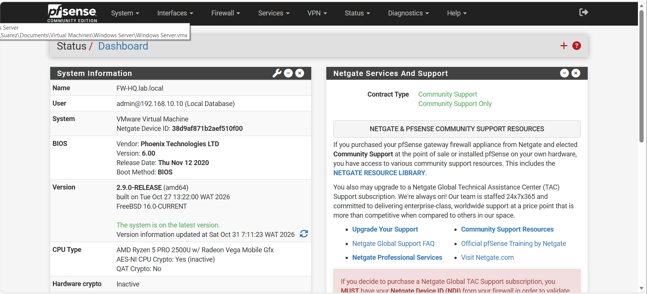
Figure 22: FW-HQ System Dashboard & Cryptographic Status — Dashboard overview highlighting admin session from 192.168.10.10, system uptime, and active AES-NI CPU cryptographic acceleration.

Section 5 — Inter-Firewall Transit Rules & ICMP Telemetry
In enterprise network operations, network engineers must be capable of diagnosing transit reachability between perimeter gateways. Because pfSense drops all unsolicited inbound WAN packets by default, an explicit firewall rule must be constructed on FW-HQ to permit ICMP Echo Requests across the simulated WAN:
- Rule Parameters: Action: Pass | Disabled: Unchecked | Interface: WAN | Address Family: IPv4 | Protocol: ICMP | ICMP Subtypes: Echo Request.
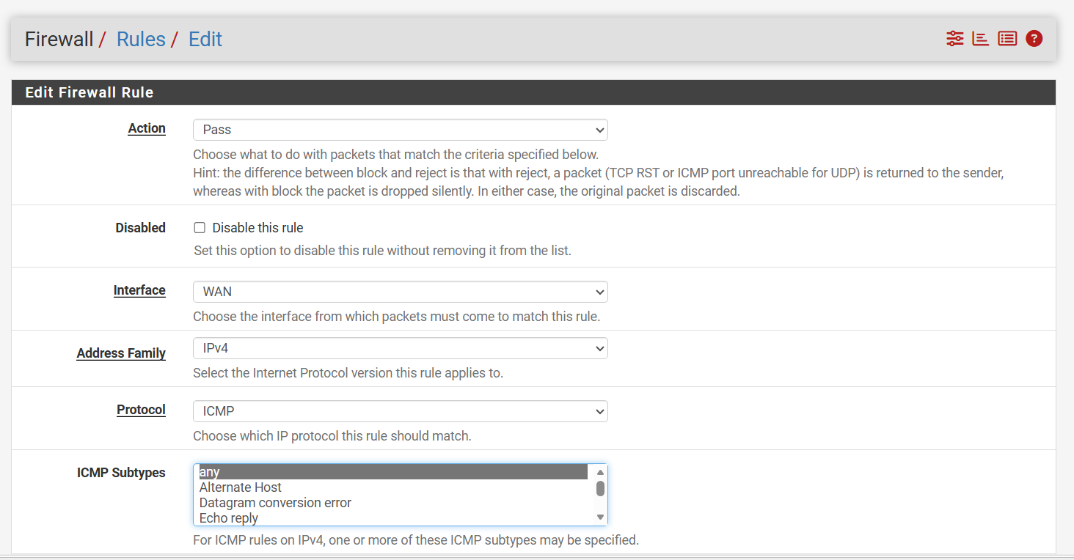
Figure 23: Creating WAN ICMP Inspection Rule — Configuring an explicit pass rule for IPv4 ICMP Echo Requests on the WAN interface of FW-HQ.
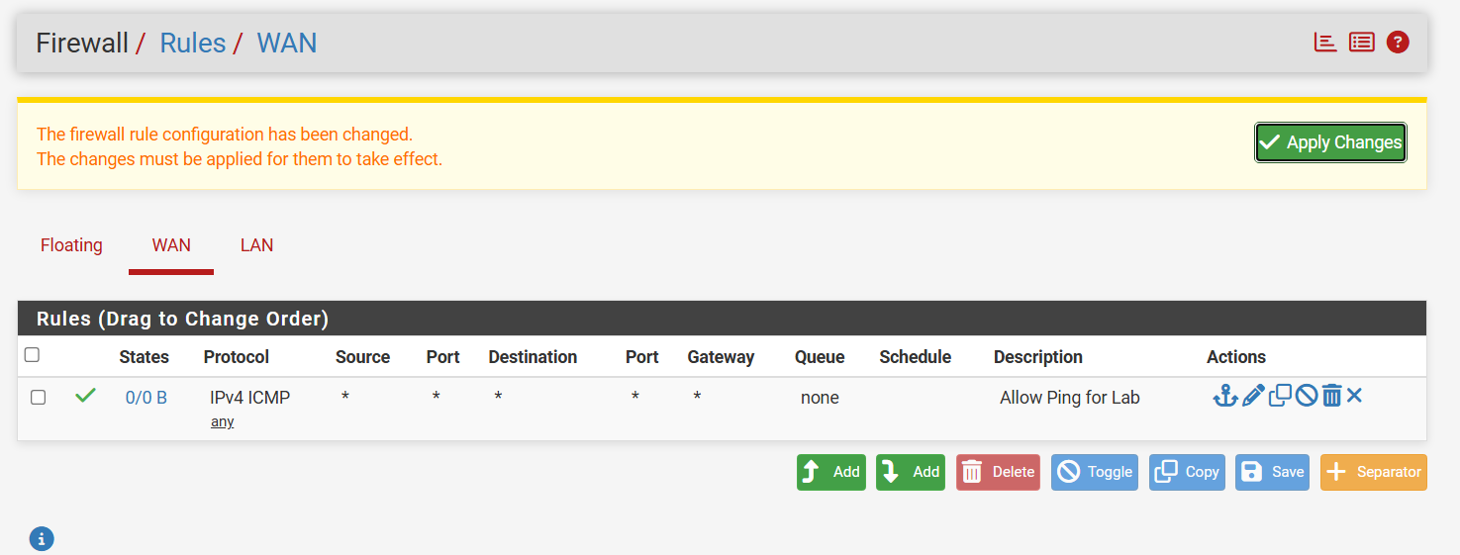
Figure 24: Active WAN Firewall Ruleset on FW-HQ — The Firewall / Rules / WAN table displaying the active 'Allow Ping for Lab' rule with rule actions and packet state counters.

Section 6 — Branch Office Provisioning & Administrative Security
Moving to the Branch Office environment, connectivity is established from the Branch PC (192.168.20.x). Command-line tests confirm local reachability to FW-Branch (192.168.20.1) and outbound routing to 8.8.8.8:
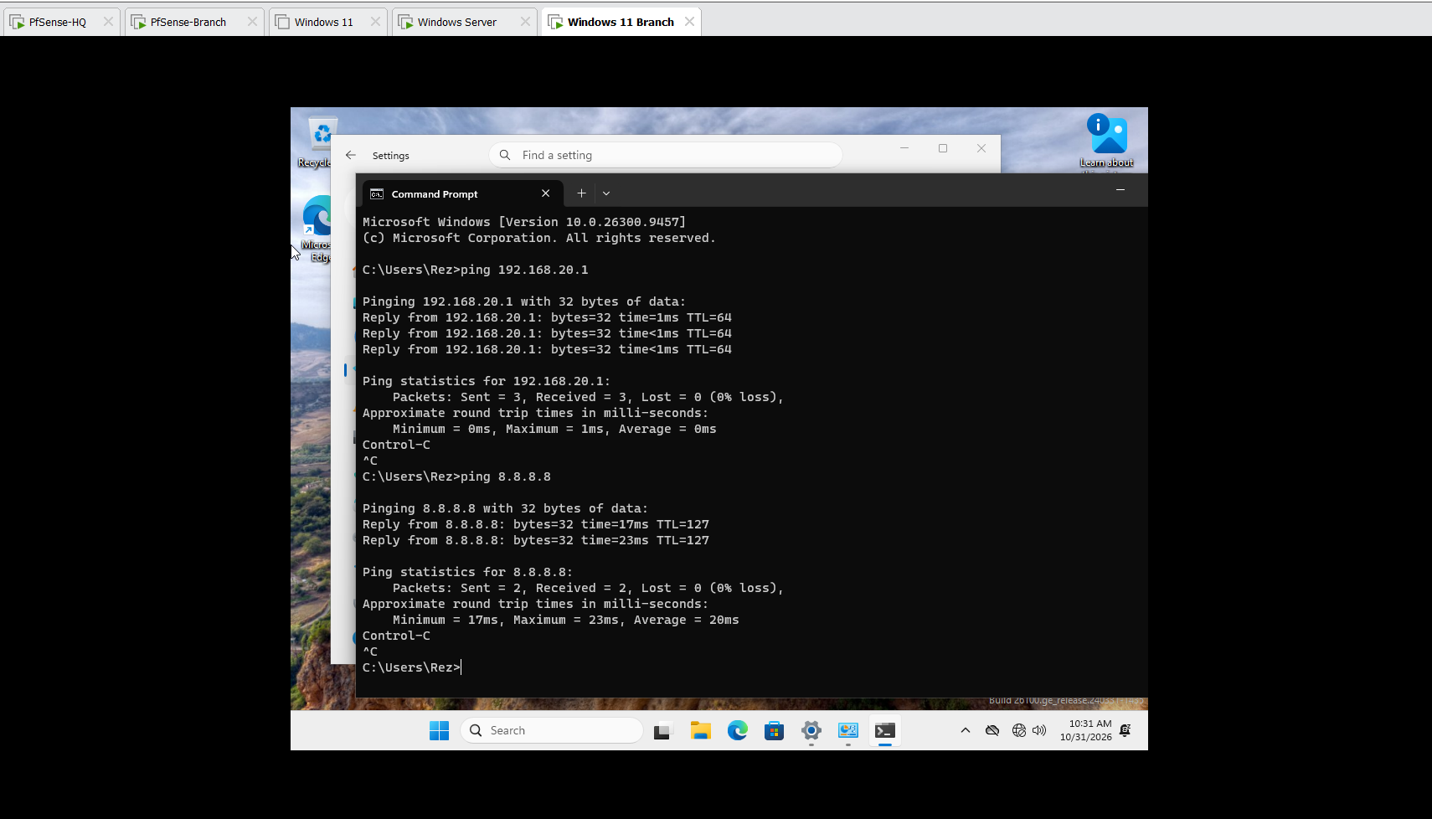
Figure 25: Branch PC Local & Internet Gateway Verification — Branch PC executing zero-latency pings to local gateway 192.168.20.1 and internet targets over FW-Branch.
From the Branch PC, the FW-Branch management console is accessed at https://192.168.20.1. The Setup Wizard is executed to define Hostname: 'FW-Branch', Domain: 'lab.local', and the default administrative password is immediately changed to a hardened enterprise credential ('PFSense123!'):
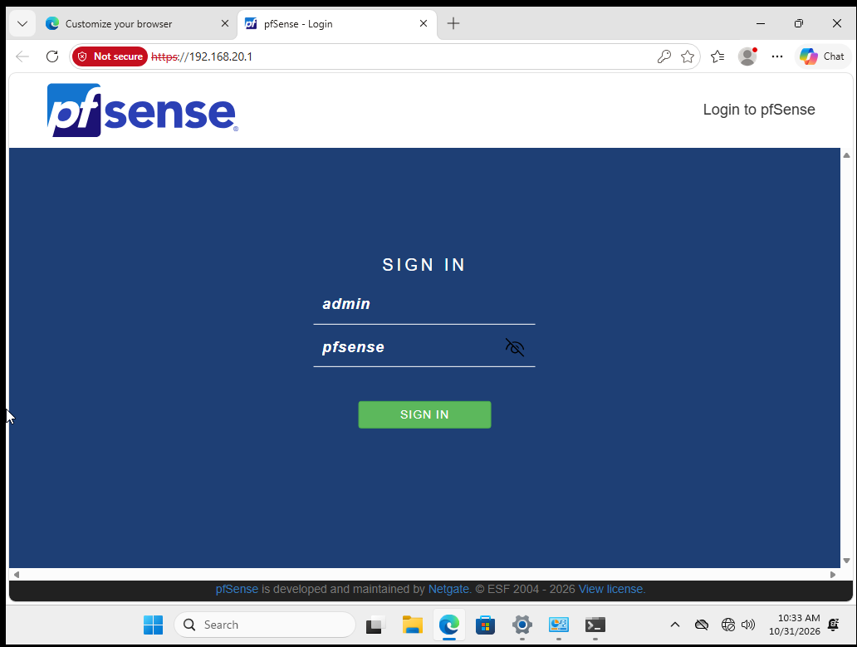
Figure 26: FW-Branch WebGUI Login Screen — Accessing the secondary firewall management gateway from the Branch workstation at https://192.168.20.1.
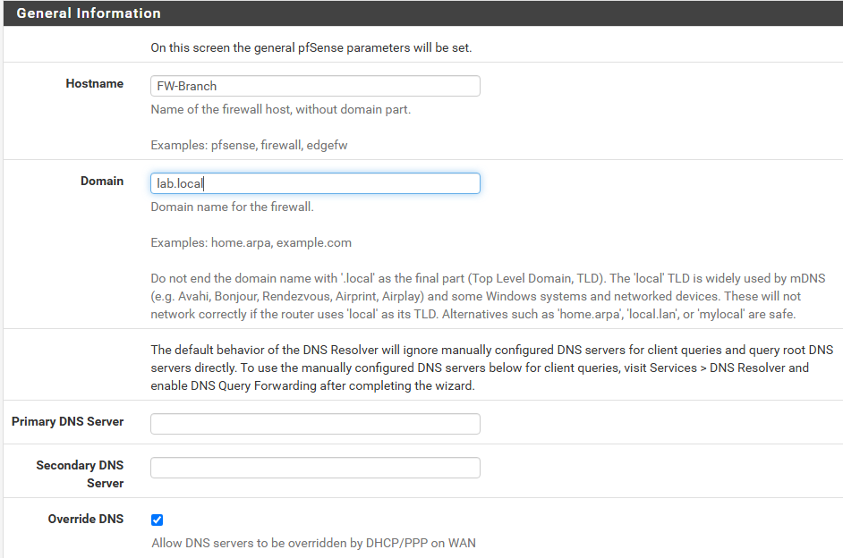
Figure 27: FW-Branch System Hostname Definition — Assigning Hostname (FW-Branch) and Domain (lab.local) during initial appliance onboarding.
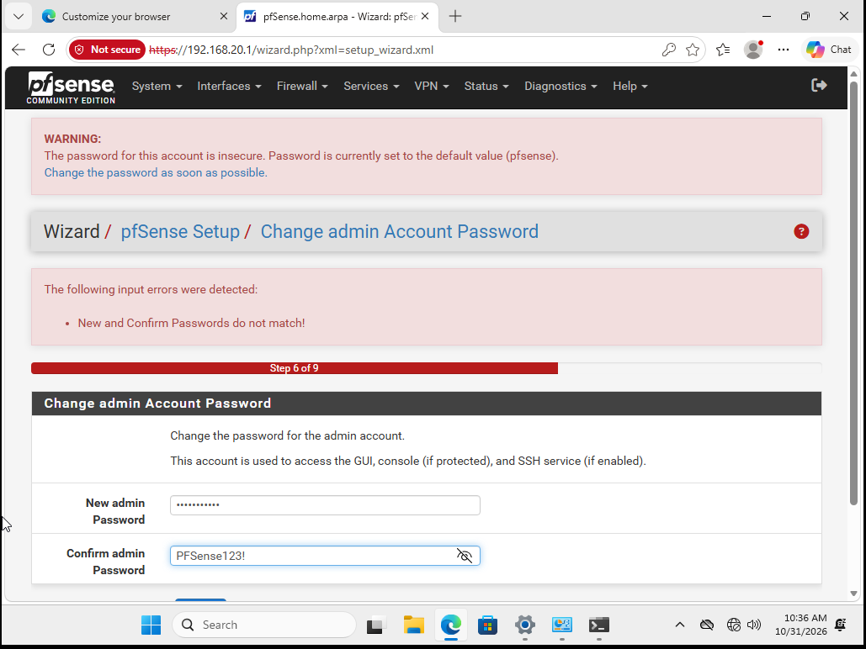
Figure 28: Admin Account Password Hardening — Enforcing strong credential management by updating the administrative password to 'PFSense123!'.
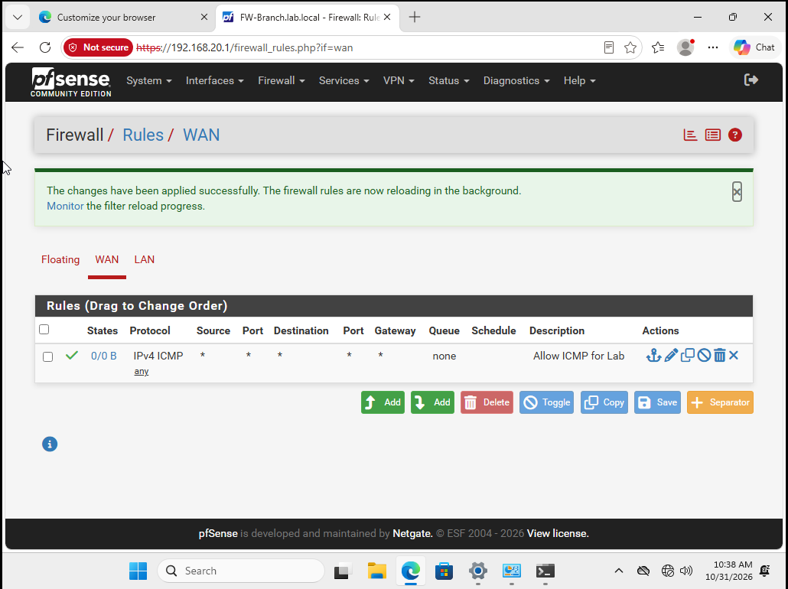
Figure 29: FW-Branch Active WAN Firewall Rules — Applying the reciprocal 'Allow ICMP for Lab' rule on FW-Branch WAN to authorize inter-firewall diagnostic probing.

Section 7 — Deep Packet Inspection & Diagnostic Verification
To definitively prove that packets are traversing interfaces, undergoing Network Address Translation, and adhering to firewall rules, pfSense's built-in Packet Capture engine (Diagnostics > Packet Capture) was executed across the em0 (WAN) interfaces of both appliances.
On FW-Branch, a packet capture on em0 reveals incoming and outgoing ICMP echo requests and replies traversing between 192.168.23.139 and upstream gateway 192.168.23.2, alongside DNS queries on UDP port 53:
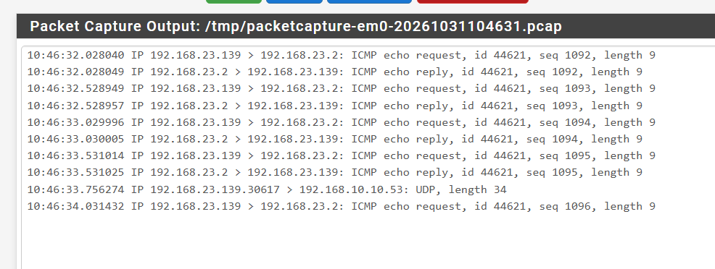
Figure 30: FW-Branch WAN Packet Capture Analysis — Raw packet capture on em0 displaying sequential ICMP sequence IDs (1092-1096) and UDP port 53 transactions, validating bidirectional transit.
Similarly, on FW-HQ, capturing WAN traffic confirms stateful NAT operation: outbound UDP traffic originating from internal source port 22616 is translated to the firewall's public WAN IP (192.168.23.138) and routed to external destination 23.32.248.77 on Port 443:
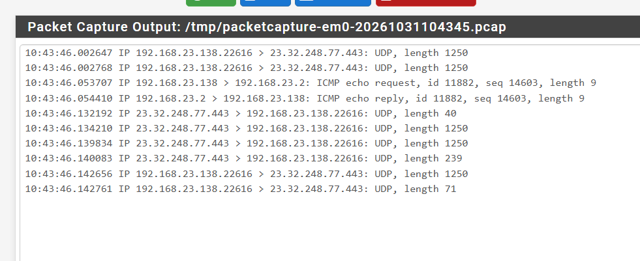
Figure 31: FW-HQ NAT Translation Packet Inspection — Packet capture confirming outbound UDP translations and ICMP round-trip replies, proving operational firewall egress.

Chapter 4 — Enterprise Identity Integration: Windows Server NPS (RADIUS) & pfSense AAA
In an enterprise architecture, network edge devices (firewalls, VPN gateways, wireless controllers, 802.1X switches) must NEVER store local user databases. Managing local credentials on individual firewalls causes password desynchronization, prevents centralized auditing, and creates catastrophic security vulnerabilities during employee offboarding.
The enterprise standard is centralized Authentication, Authorization, and Accounting (AAA) brokered via the Remote Authentication Dial-In User Service (RADIUS) protocol. In a Microsoft ecosystem, this role is fulfilled by Network Policy Server (NPS), which acts as a secure bridge between the pfSense perimeter gateway and Active Directory Domain Services.

Section 1 — The Centralized AAA Architecture
Authentication Sequence: The end-to-end authentication flow operates as follows:
- 1. Client Request: A remote user or VPN client connects to pfSense and presents Active Directory credentials.
- 2. RADIUS Forwarding: pfSense encapsulates the credentials inside a RADIUS Access-Request packet (UDP port 1812) and forwards it to DC01.
- 3. NPS Evaluation: Windows Server NPS validates the RADIUS client IP and shared secret, queries AD DS for account validity, group membership, and dial-in authorization.
- 4. Access Verdict: NPS evaluates its Network Policies and returns a RADIUS Access-Accept or Access-Reject packet to pfSense.
- 5. Session Enforcement: pfSense permits or denies the session without ever needing to know the user's password locally.

Section 2 — Installing & Authorizing Network Policy Server in Active Directory
On DC01, Server Manager is utilized to install the 'Network Policy and Access Services' (NPAS) role along with Remote Server Administration Tools (RSAT):
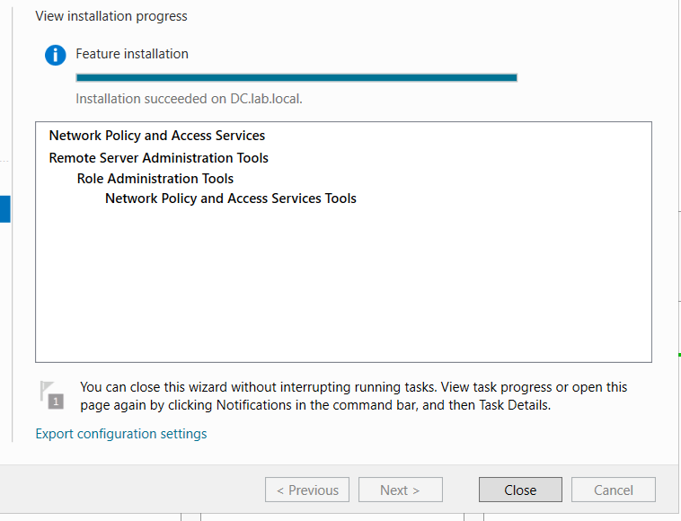
Figure 32: NPAS Role Installation Completion — Server Manager confirming successful deployment of Network Policy and Access Services and management tools on DC.lab.local.
Crucially, NPS cannot evaluate user authorization until it is registered as an authorized dial-in server in the Active Directory domain. Within the Network Policy Server console (nps.msc), the root node 'NPS (Local)' is right-clicked and 'Register server in Active Directory' is selected:
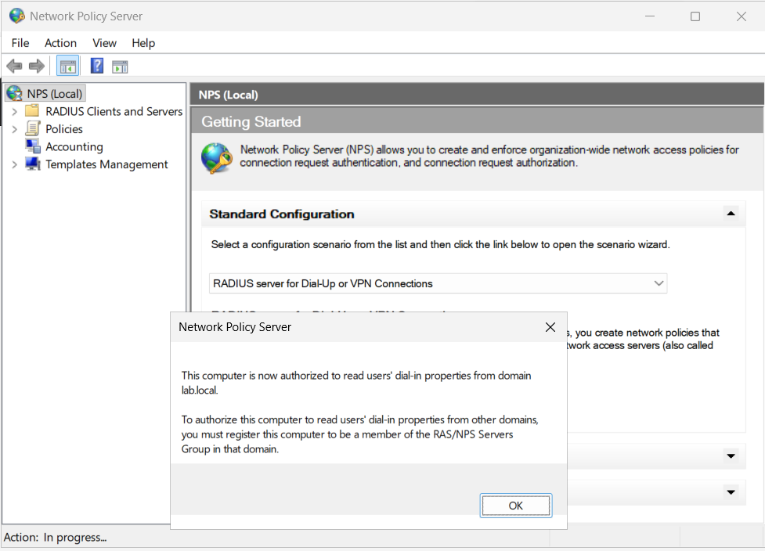
Figure 33: Authorizing NPS in Active Directory — Authorizing the NPS server in the domain, granting it read permissions for user dial-in properties across the LAB domain.

Section 3 — Registering pfSense as a RADIUS Client in NPS
RADIUS Client Definition: To establish trust between pfSense and Windows Server, pfSense must be registered as a valid RADIUS client. Under RADIUS Clients and Servers > RADIUS Clients, a new client entry is created with the following parameters:
- Friendly Name: pfSense-HQ (for clear administrative auditing).
- Address (IP or DNS): 192.168.10.1 (The internal LAN interface of FW-HQ that sends RADIUS packets).
- Shared Secret: Manual > 'Pass123' (A shared cryptographic key known only to NPS and pfSense).
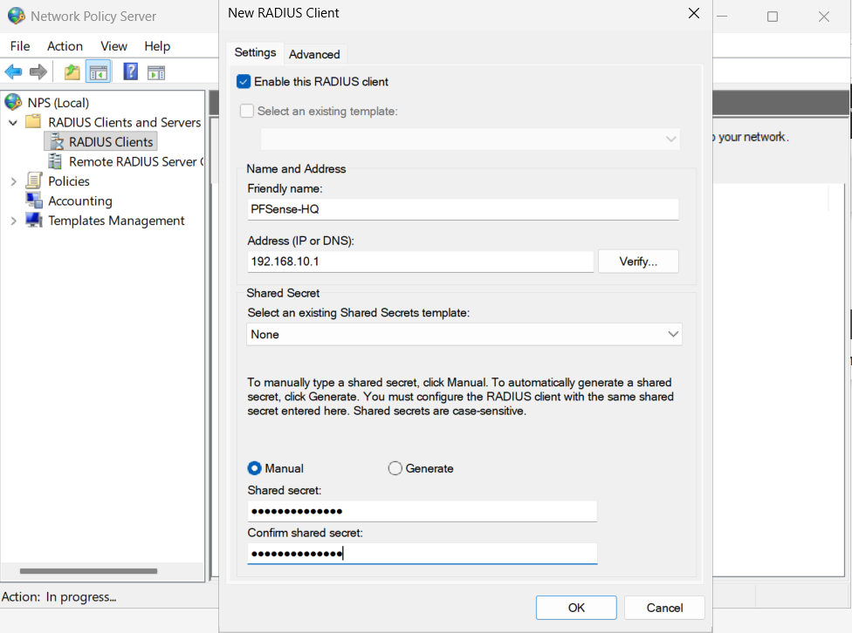
Figure 34: RADIUS Client Definition in NPS — Registering pfSense-HQ (192.168.10.1) with shared secret 'Pass123' to authenticate incoming AAA requests.

Section 4 — Authoring the Enterprise Network Access Policy
Network Policy Server uses rule-based Network Policies to govern who is authorized to connect. Under Policies > Network Policies, a new policy named 'VPN-Allow' is created. The wizard guides four critical parameters:
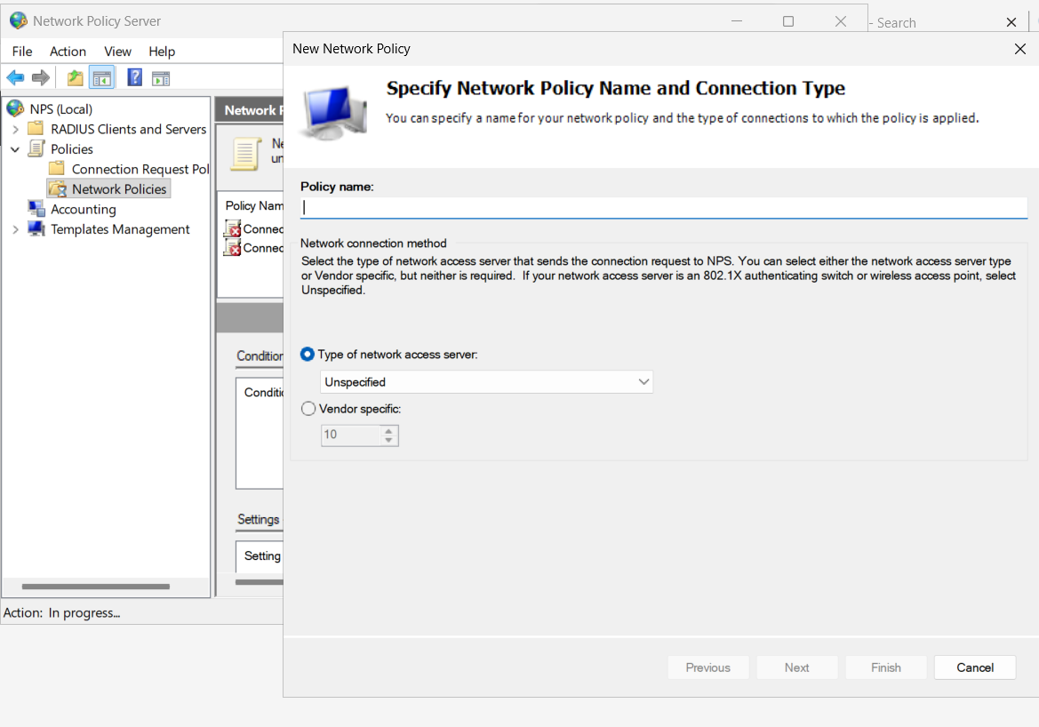
Figure 35: NPS Policy Creation: Name & Type — Naming the policy 'VPN-Allow' and designating network access server type as Unspecified / Virtual (VPN).
Conditions define who triggers the policy. Condition 'User Groups' is added and pointed to the Active Directory group 'LAB\Domain Users' (in high-security production environments, this is typically restricted to a dedicated security group such as 'GG_VPN_Allowed'):
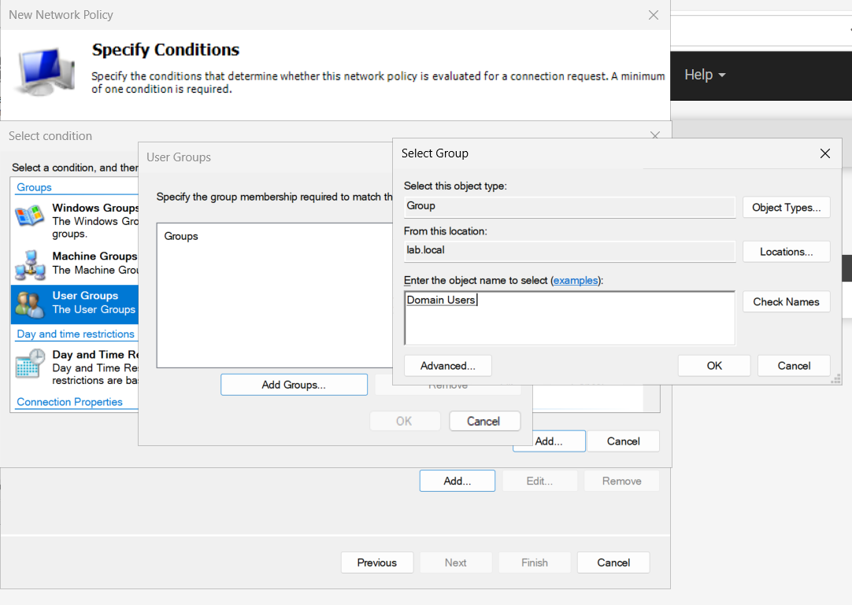
Figure 36: Selecting Policy Conditions: User Groups — Selecting the 'User Groups' condition type and browsing Active Directory object locations.
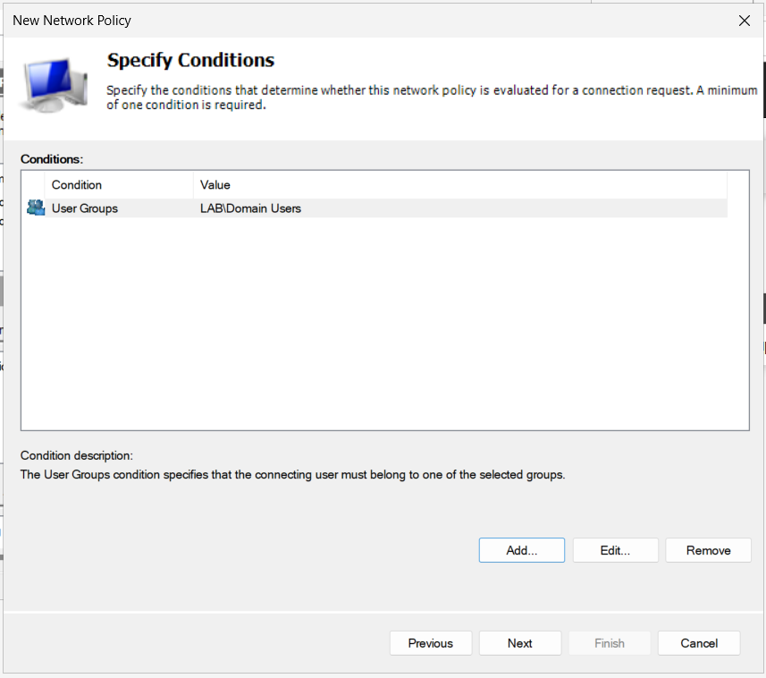
Figure 37: Configuring User Groups Condition — Assigning LAB\Domain Users as the required group membership condition for remote network access.
Next, the access permission is explicitly set to 'Access granted':
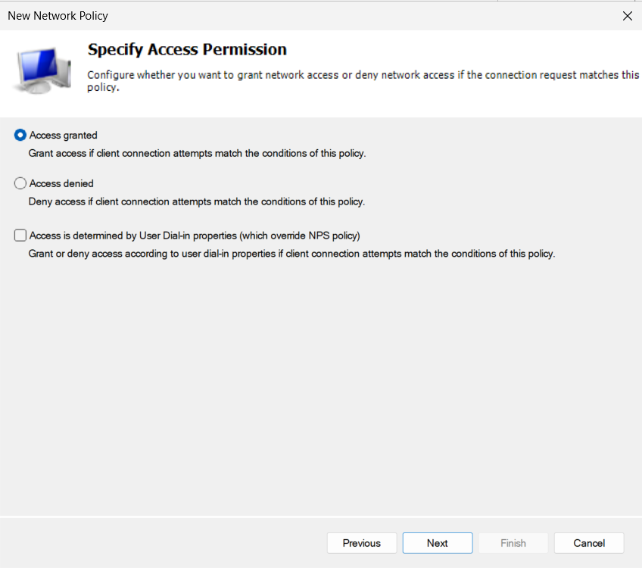
Figure 38: Specifying Access Permission — Selecting 'Access granted' to permit network connection attempts matching all configured criteria.
For authentication methods, modern security mandates 'Microsoft Encrypted Authentication version 2 (MS-CHAP-v2)'. Legacy, cleartext, or weak authentication mechanisms (such as PAP, SPAP, and CHAP) are explicitly unchecked to eliminate credential theft:
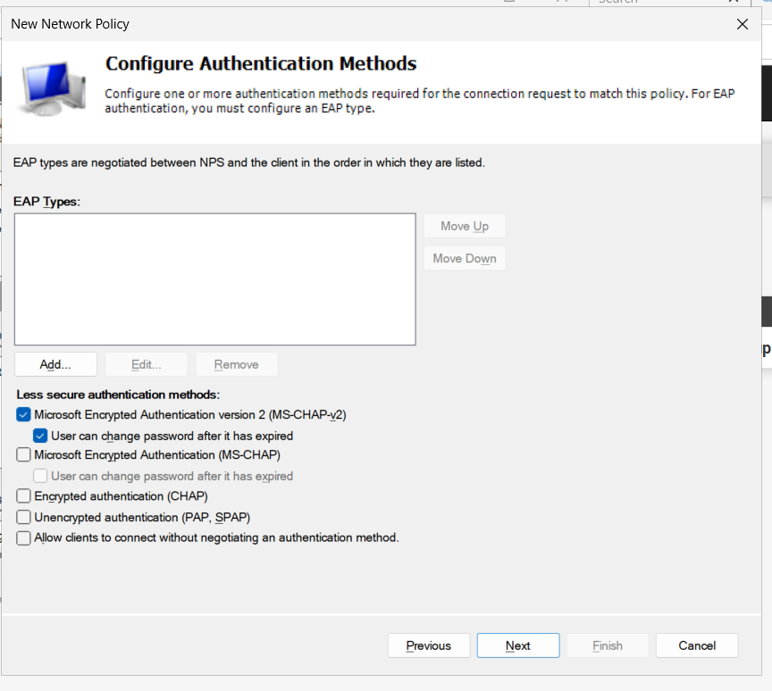
Figure 39: Enforcing MS-CHAP-v2 Cryptographic Authentication — Restricting authentication exclusively to MS-CHAP-v2 while stripping insecure plain and weak cipher handshakes.
The completed policy summary is reviewed, confirming that connecting users belonging to LAB\Domain Users will be granted access over MS-CHAP-v2 with Framed protocol support. The policy is committed to active processing:
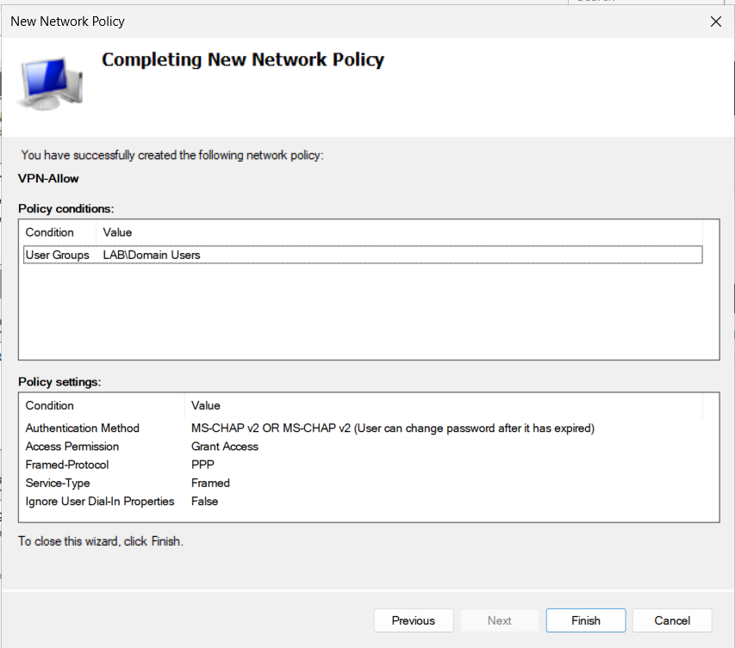
Figure 40: Network Policy Completion Summary — Verification summary displaying policy condition, MS-CHAP-v2 authentication, and access granted verdict.
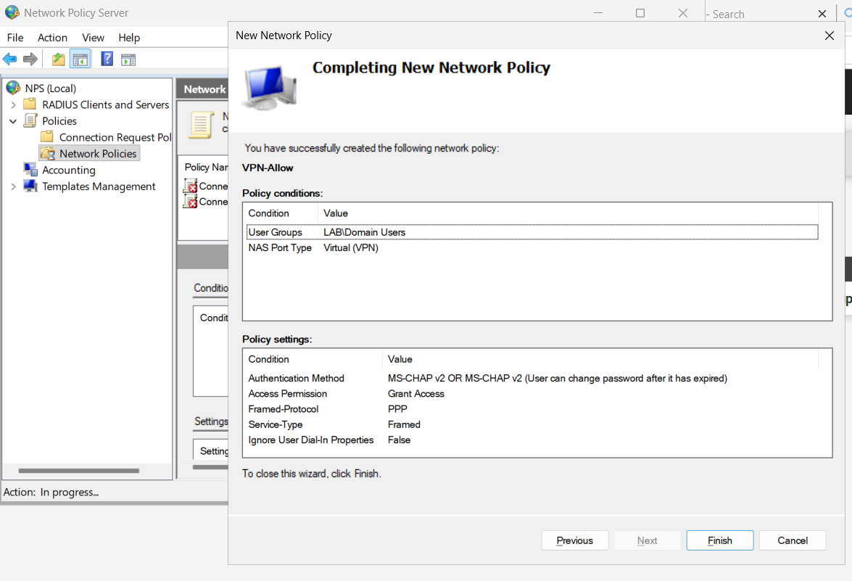
Figure 41: Active Network Policy List with VPN Profile — The final policy table listing VPN-Allow configured for Virtual (VPN) NAS port types, ready to service RADIUS queries.

Section 5 — Validating RADIUS AAA Integration from pfSense
Before deploying end-user VPN tunnels, the entire AAA pipeline must be validated directly between pfSense and DC01. Within pfSense, the RADIUS server is defined under System > User Manager > Authentication Servers pointing to 192.168.10.10 on port 1812 with shared secret 'Pass123'.
Navigation to Diagnostics > Authentication allows testing credentials directly against the server. Testing the domain account 'Administrator' against server 'AD-DC-RADIUS' returns immediate success: 'User Administrator authenticated successfully. This user is a member of groups: Domain Admins, etc.'
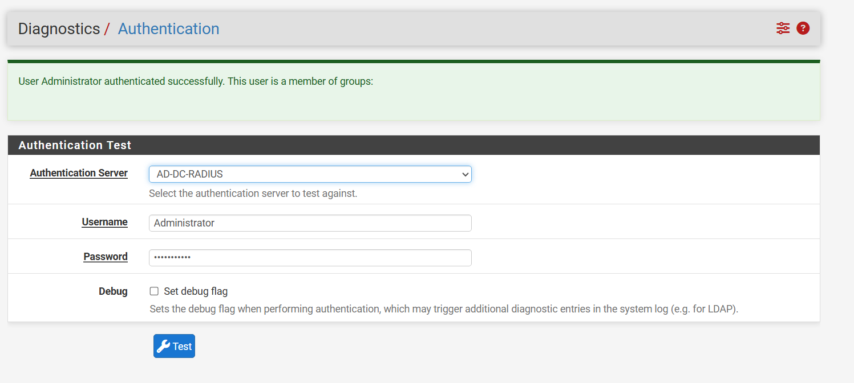
Figure 42: pfSense RADIUS Authentication Proof — Diagnostic confirmation of successful RADIUS authentication against AD-DC-RADIUS, validating the entire AAA pipeline.

Chapter 5 — Public Key Infrastructure (PKI) & Enterprise IKEv2 Mobile Client VPN
Enterprise mobility demands robust, secure remote access. Rather than relying on outdated protocols like PPTP or L2TP (which are vulnerable to credential harvesting or blocked by intermediate NAT devices), enterprise networks deploy IKEv2 (Internet Key Exchange version 2) over IPsec. IKEv2 offers superior cryptographic strength, rapid re-authentication, and seamless connection roaming via MOBIKE (IKEv2 Mobility and Multihoming Protocol).
Crucially, Windows native VPN clients require asymmetric mutual authentication for IKEv2: the firewall proves its identity using a digital X.509 certificate signed by a Certificate Authority trusted by the client, while the client authenticates using Active Directory credentials via EAP-RADIUS. Chapter 5 establishes the internal PKI and deploys the enterprise IKEv2 VPN.

Section 1 — Establishing the Internal Certificate Authority (Lab-CA)
Internal CA Parameters: To sign server certificates without incurring public CA costs for internal lab infrastructure, pfSense's integrated Certificate Manager (System > Certificates > Authorities) is utilized to instantiate an internal root CA:
- Descriptive Name: Lab-CA.
- Method: Create an internal Certificate Authority.
- Key Type: RSA 2048-bit (adheres to NIST minimum key length recommendations).
- Digest Algorithm: SHA256 (prevents collision attacks associated with deprecated SHA1).
- Lifetime: 3650 days (10 years, standard for root anchors).
- Common Name (CN): Lab-CA.
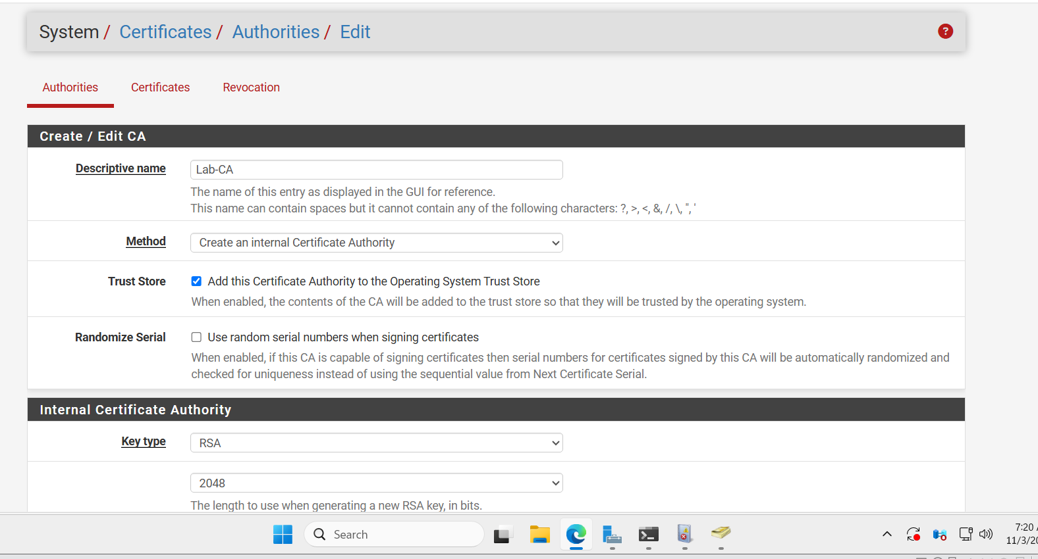
Figure 43: Creating Internal Certificate Authority (Lab-CA) — Initializing the internal CA in pfSense with RSA 2048-bit key generation and operating system trust store integration.
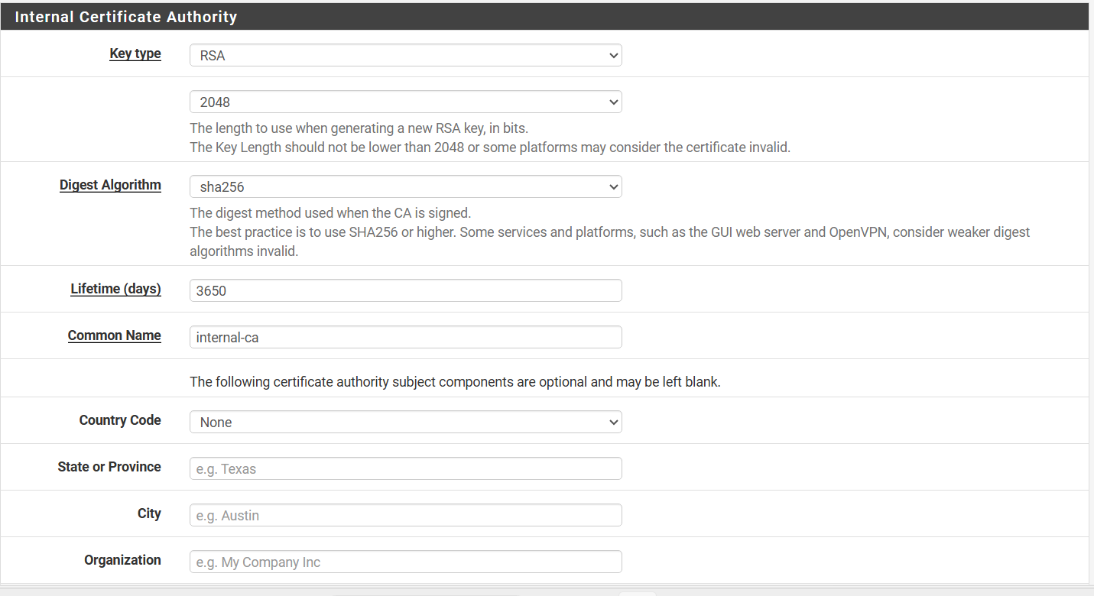
Figure 44: Cryptographic Digest & Authority Parameters — Configuring SHA256 hashing, 3650-day validity, and assigning CN=Lab-CA.
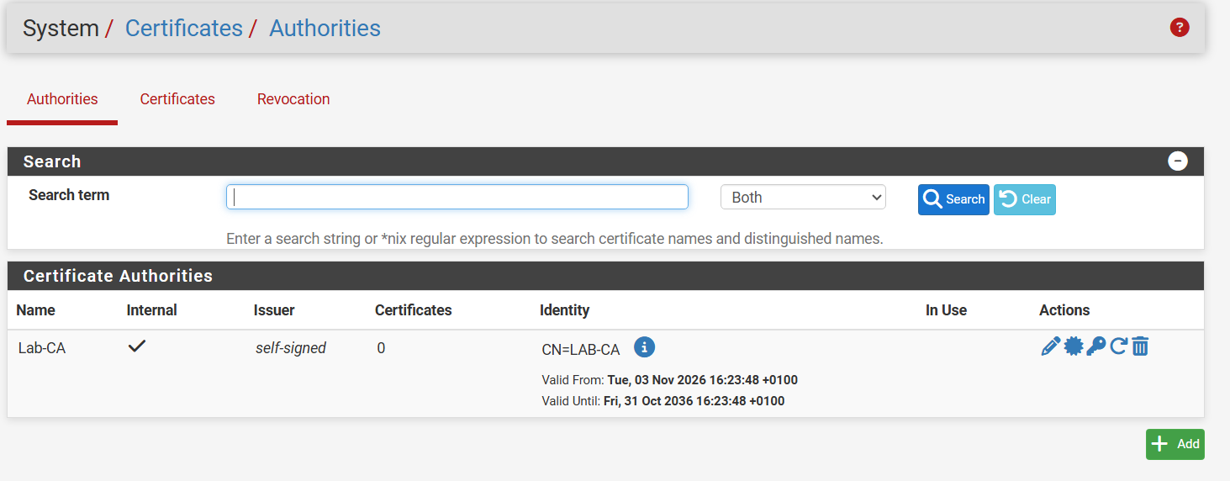
Figure 45: Active Certificate Authorities List — Overview of active CAs confirming Lab-CA is self-signed, healthy, and valid through October 2036.
Once generated, the root certificate must be exported from pfSense (via the 'Export CA' icon) as 'Lab-CA.crt'. This file will be deployed to all remote client endpoints to establish cryptographic trust for incoming VPN connections:
Figure 46: Exported Lab-CA.crt Certificate File — The exported public CA certificate saved on the administrator workstation, ready for endpoint trust store deployment.

Section 2 — Generating the VPN Server Certificate (VPN-Server-Cert)
With the root CA operational, a dedicated server certificate is generated under System > Certificates > Certificates. This certificate is presented by pfSense during the initial IKE SA negotiation to prove the firewall's authentic identity to connecting clients.
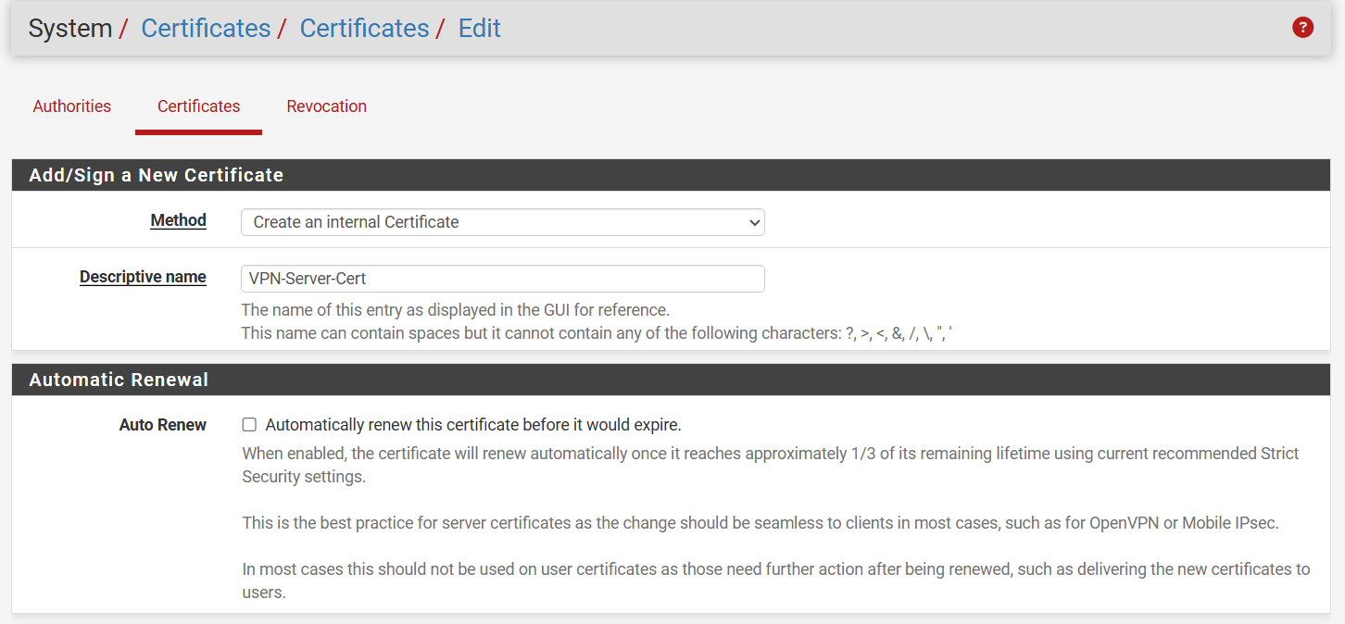
Figure 47: Add/Sign Internal Server Certificate — Creating an internal certificate titled 'VPN-Server-Cert' with automatic renewal enabled.
The certificate is signed by 'Lab-CA' with an RSA 2048-bit key and SHA256 digest. The Common Name (CN) is set to the firewall's external WAN IP address (192.168.23.138):
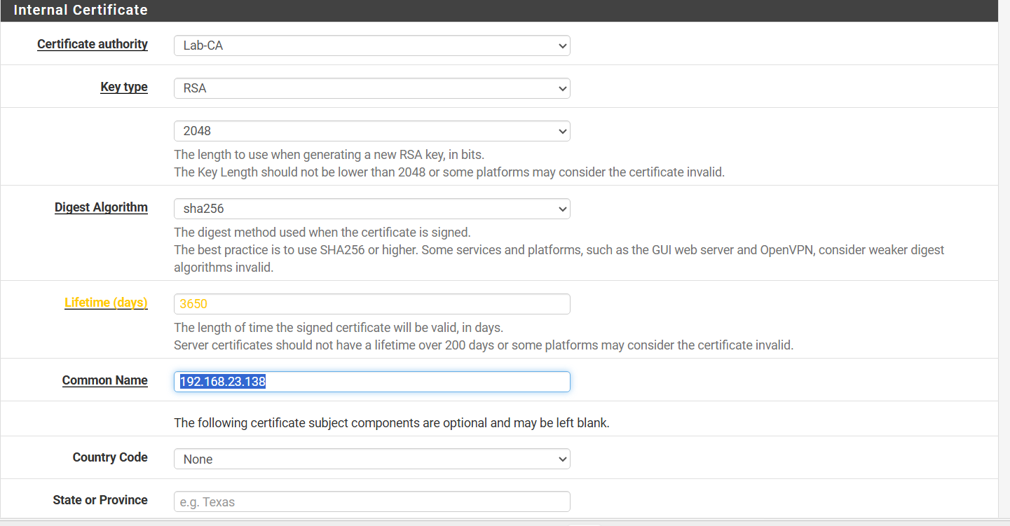
Figure 48: Server Certificate Cryptographic Parameters — Binding the certificate to Lab-CA with Common Name set to the external WAN address (192.168.23.138).
[CRITICAL WINDOWS IKEv2 SAN REQUIREMENT] The Subject Alternative Name (SAN) Requirement: The built-in Windows IKEv2 VPN client will strictly reject any server certificate if the IP address or FQDN entered in the Windows VPN connection does not match an entry in the certificate's Subject Alternative Name (SAN) extension! Simply having the IP in the Common Name (CN) is no longer sufficient. An explicit SAN entry (Type: IP address, Value: 192.168.23.138) MUST be added, and Certificate Type must be designated as 'Server Certificate'. Omitting this triggers Windows Error 13801.

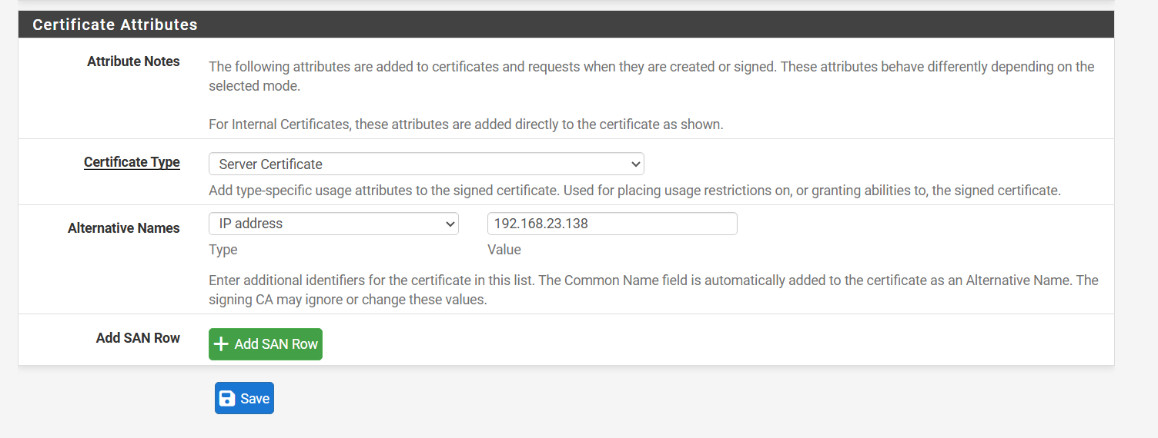
Figure 49: Enforcing Server Certificate Type & IP SAN — Designating Certificate Type as 'Server Certificate' and explicitly appending SAN Type: IP Address = 192.168.23.138 to satisfy Windows IKEv2 validation.

Section 3 — Configuring IPsec Mobile Client Core Settings
Mobile Client Configuration: With PKI established, IPsec Mobile Client support is activated under VPN > IPsec > Mobile Clients. The settings bridge the tunnel endpoints into Active Directory and automate client IP assignment (mode-cfg):
- Enable IPsec Mobile Client Support: Checked (enables remote dial-in server).
- User Authentication: AD-DC-RADIUS (offloads user credential verification to Windows Server NPS).
- Virtual Address Pool: 10.10.100.0/24 (an isolated virtual pool dynamically assigned to remote clients).
- DNS Default Domain: lab.local (pushes the internal search suffix to remote adapters).
- DNS Servers: 192.168.10.10 (directs mobile clients to query DC01 for enterprise AD resolution).
- Phase 2 PFS Group: Off (overrides mobile client Phase 2 PFS to maximize client compatibility).
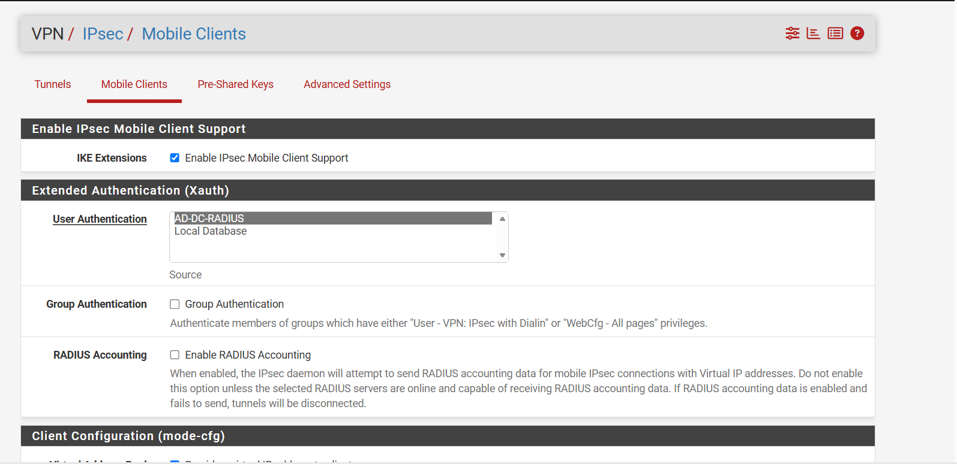
Figure 50: Enabling Mobile Client Support & RADIUS AAA — Enabling mobile client support and binding authentication to the AD-DC-RADIUS server.
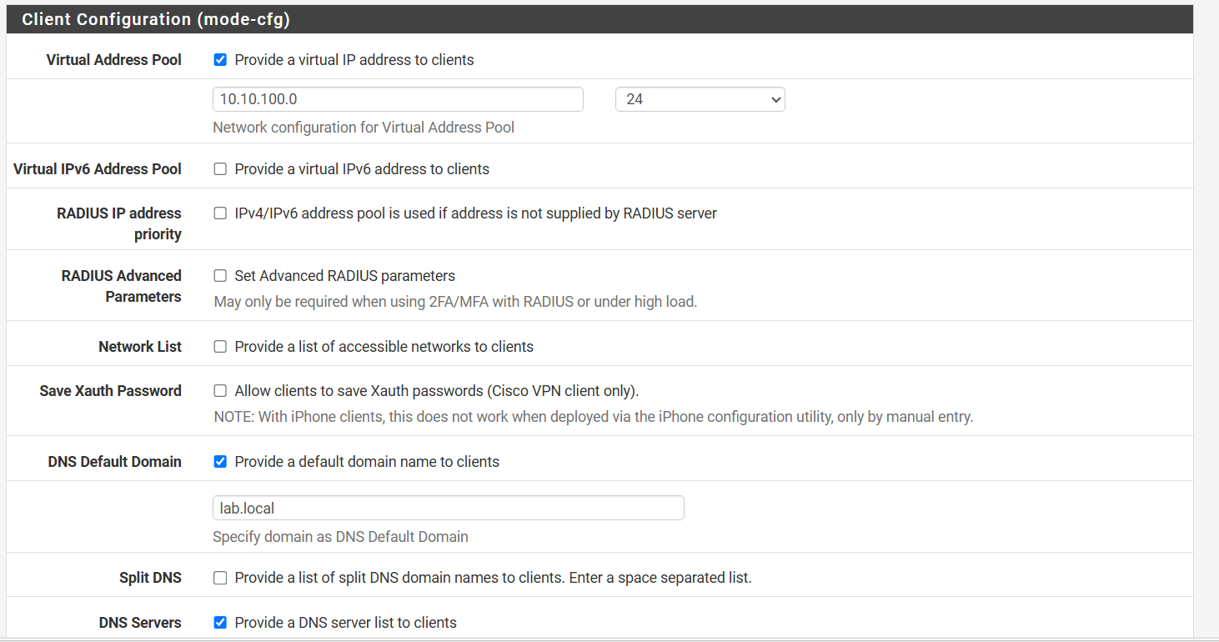
Figure 51: Virtual IP Pool & Domain Propagation — Defining virtual pool 10.10.100.0/24 and pushing default search domain lab.local to remote endpoints.
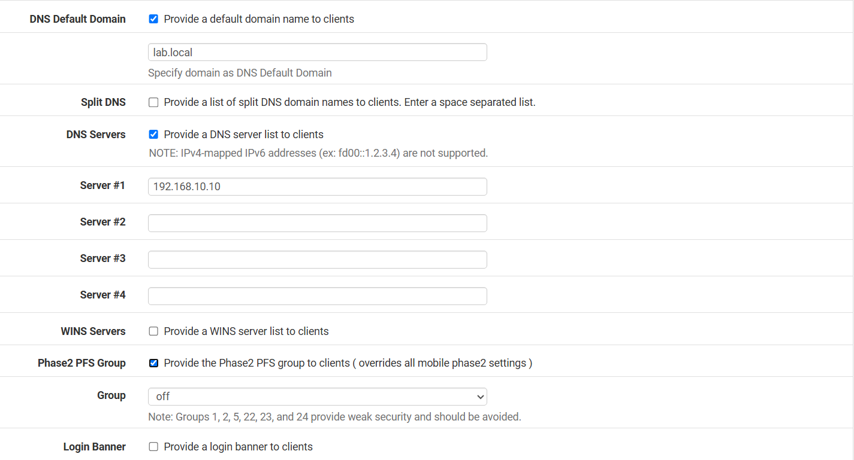
Figure 52: Internal DNS Assignment (DC01) — Assigning DC01 (192.168.10.10) as primary DNS server for all connected mobile clients.

Section 4 — Authoring the IPsec Phase 1 Proposal (IKE SA)
IPsec operates in two distinct cryptographic negotiation phases. Phase 1 (IKE SA) establishes an authenticated, encrypted control channel between the client and pfSense. Under VPN > IPsec > Tunnels, a new Phase 1 entry is created:
- Description: IKEv2 Remote Access (AD).
- Key Exchange Version: IKEv2 (mandatory for modern mobile devices and native Windows VPN).
- Endpoint: IPv4 on WAN interface.
- Authentication Method: EAP-RADIUS (requires server certificate on pfSense and user credentials via RADIUS).
- My Identifier: IP address 192.168.23.138 (matches the server certificate SAN).
- Peer Identifier: Any.
- My Certificate: VPN-Server-Cert.
- Encryption Algorithm: AES 256-bit, SHA256 hash, Diffie-Hellman Group 14 (2048-bit).
- NAT Traversal (NAT-T): Auto (encapsulates ESP inside UDP port 4500 when traversing client NAT routers).
- MOBIKE: Enabled (permits seamless IP changes when client switches from Wi-Fi to cellular).
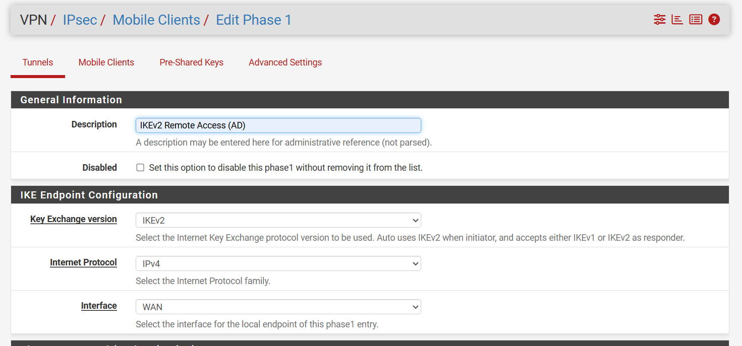
Figure 53: Phase 1 General & Endpoint Settings — Configuring IKEv2 protocol on WAN interface for mobile remote access.
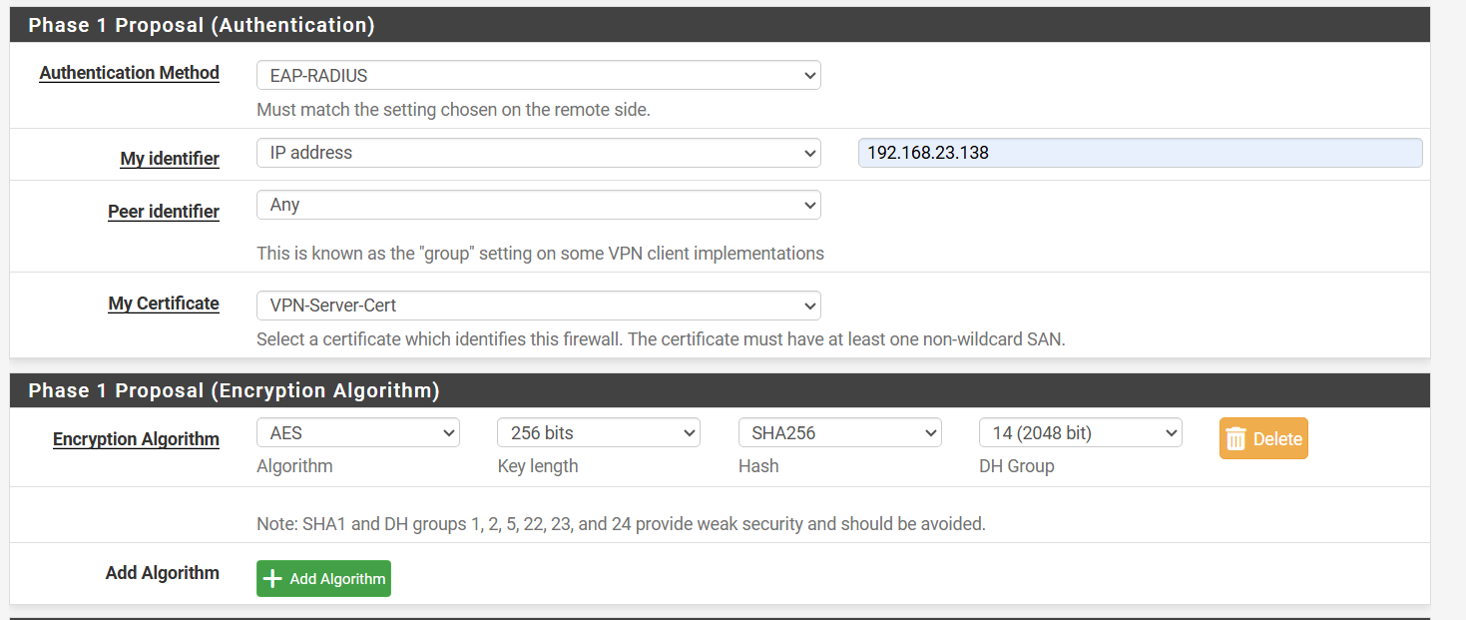
Figure 54: Phase 1 Authentication & Cryptographic Suite — Configuring EAP-RADIUS authentication, VPN-Server-Cert identity, AES-256 encryption, and DH Group 14.
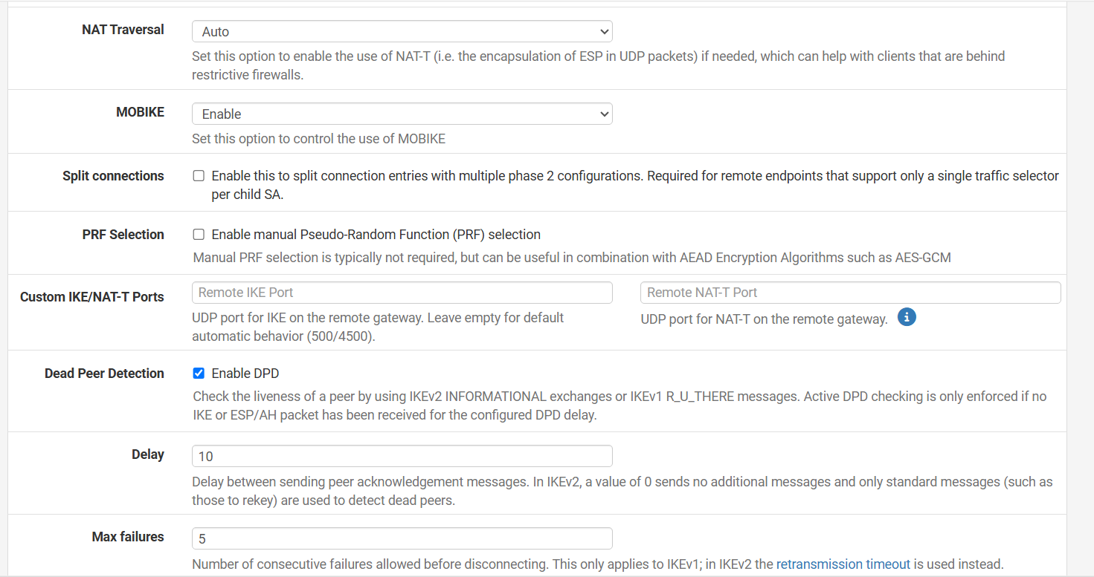
Figure 55: Advanced Parameters: NAT-T, MOBIKE & DPD — Enabling automatic NAT Traversal, MOBIKE roaming support, and Dead Peer Detection (10s delay) for tunnel health.
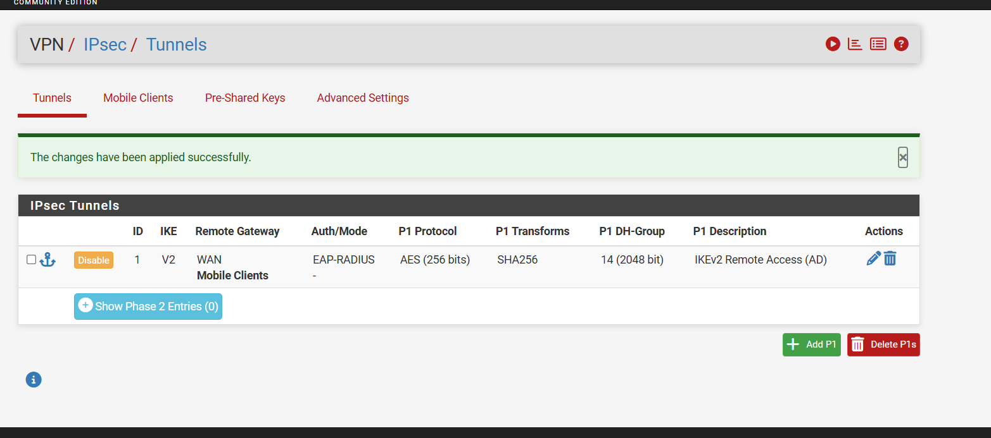
Figure 56: Active Phase 1 Proposal Summary — The IPsec Tunnels table displaying active Phase 1 profile with AES-256/SHA256/DH14 and EAP-RADIUS mode.

Section 5 — Authoring the IPsec Phase 2 Proposal (Child IPsec SA)
While Phase 1 creates the control tunnel, Phase 2 negotiates the Child Security Associations (Child SAs) that actually encrypt and encapsulate user payload traffic (e.g., SMB file shares, Kerberos auth, RDP sessions):
- Mode: Tunnel IPv4.
- Local Network: LAN subnet (192.168.10.0/24) — defines the internal resources clients can access.
- Protocol: ESP (Encapsulating Security Payload) providing confidentiality, origin authentication, and integrity.
- Encryption Algorithms: AES 256 bits, AES256-GCM 128 bits.
- Hash & PFS: SHA256, PFS Key Group: Off.
- Lifetime & Rekey: 3600 seconds (1 hour); Rekey Time: 3240 seconds (90% threshold); Rand Time: 360 seconds (prevents simultaneous rekey storms).
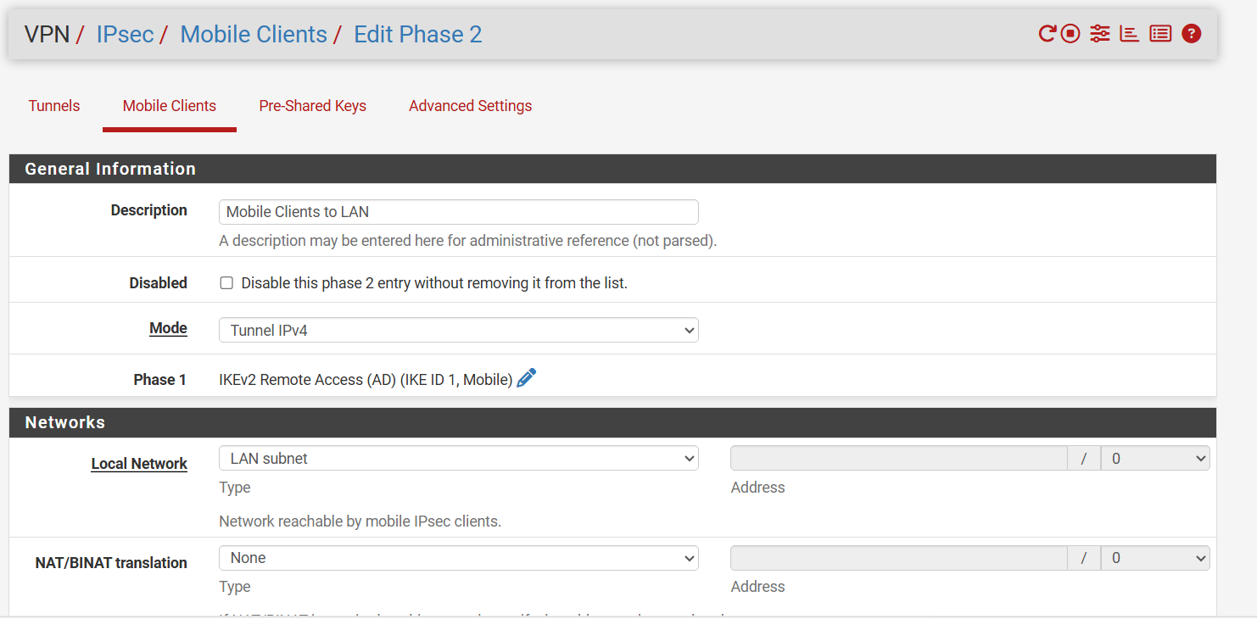
Figure 57: Phase 2 Network Selector Definition — Designating LAN subnet (192.168.10.0/24) as the accessible destination for mobile client tunnels.
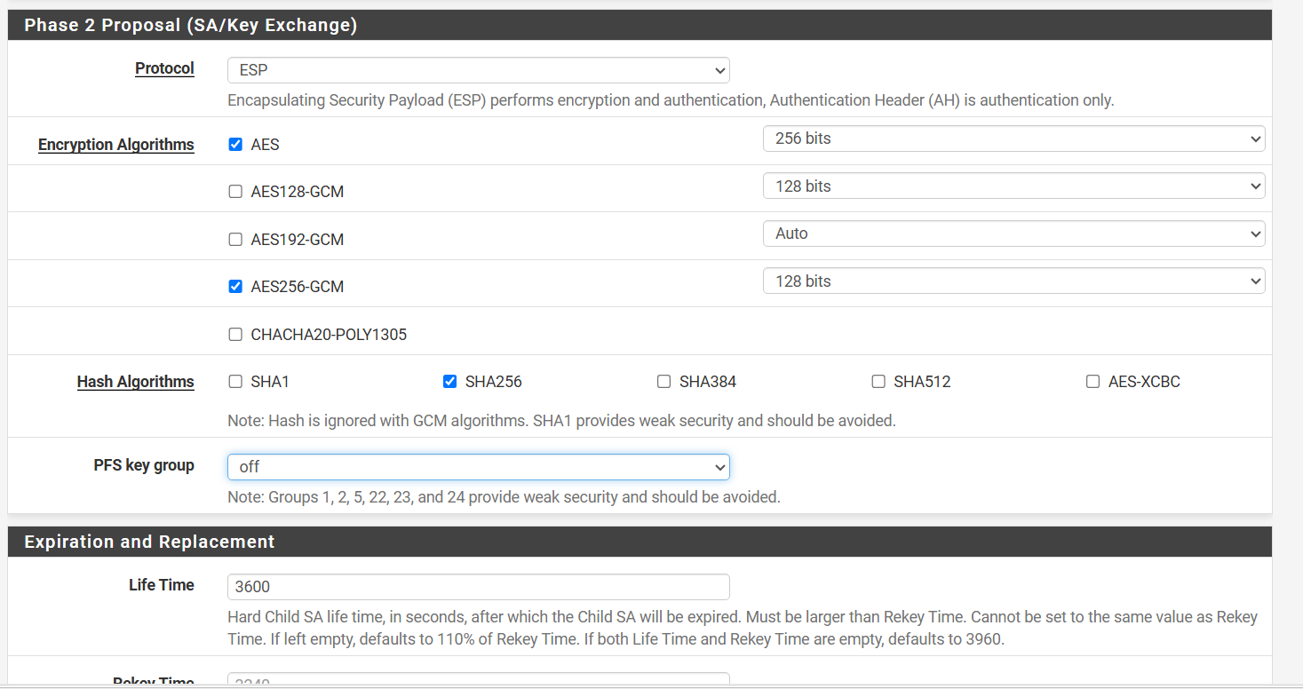
Figure 58: Phase 2 ESP Cryptographic Suite — Selecting ESP protocol with AES-256 / AES-GCM encryption and SHA256 integrity verification.
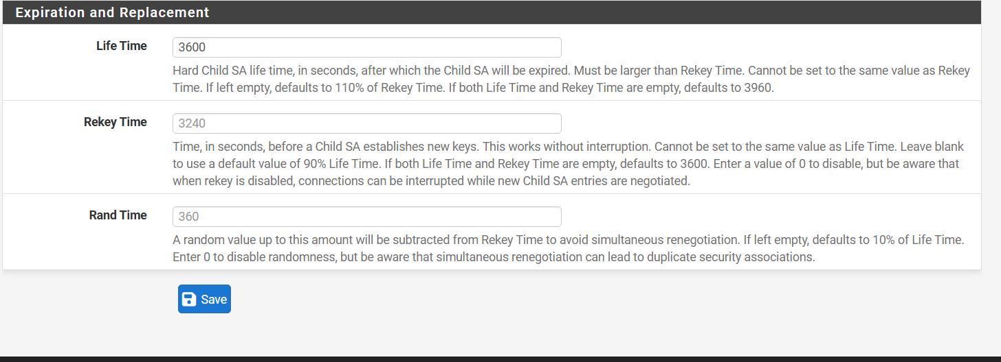
Figure 59: Phase 2 SA Lifetime & Rekey Parameters — Configuring 3600s lifetime with 3240s rekey schedule and 360s jitter randomization.
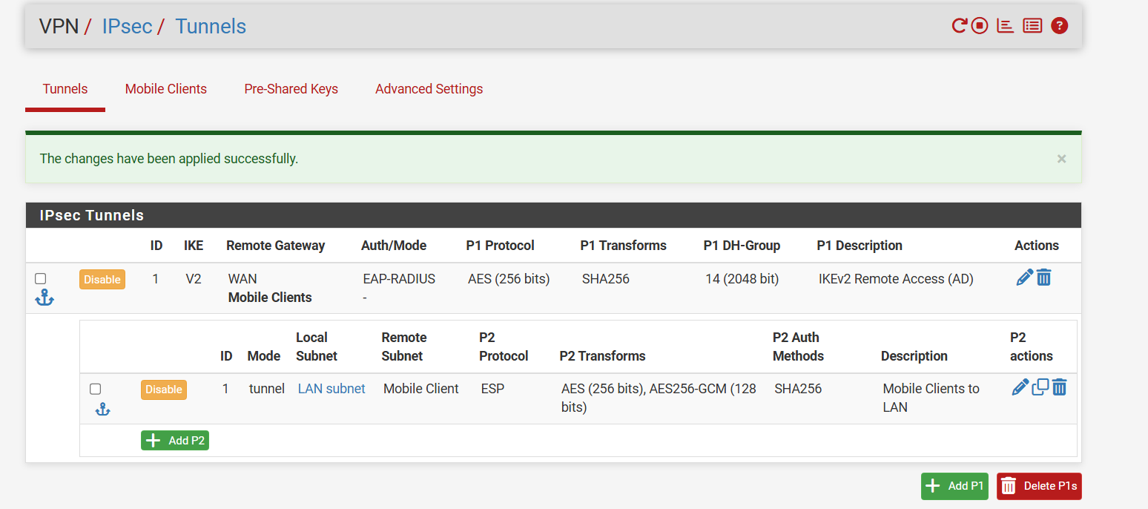
Figure 60: Completed IPsec Tunnels Configuration Overview — Master IPsec table displaying both Phase 1 (IKEv2 EAP-RADIUS) and Phase 2 (LAN Subnet ESP) in synchronized operational status.

Section 6 — State-Enforced Firewall Rules for IPsec
Two-Tier Firewall Architecture: An IPsec VPN requires two fundamentally different firewall rules on pfSense:
- 1. Handshake Rule (WAN): Applied on the WAN interface. Must allow external clients to initiate the IKE negotiation handshake. Permits UDP port 500 (ISAKMP) and UDP port 4500 (IPsec NAT-T) into the WAN IP.
- 2. Payload Traffic Rule (IPsec Interface): Applied on the virtual 'IPsec' interface tab. Governs decapsulated plain payload packets exiting the tunnel. Permits traffic originating from the virtual client pool (10.10.100.0/24) reaching internal LAN subnets (192.168.10.0/24).
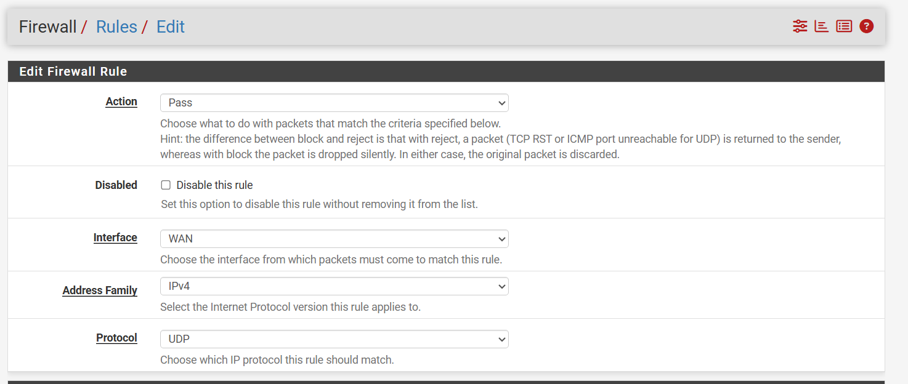
Figure 61: Creating WAN Inbound Rule for IPsec Handshake — Specifying Action: Pass, Interface: WAN, Protocol: UDP on FW-HQ.
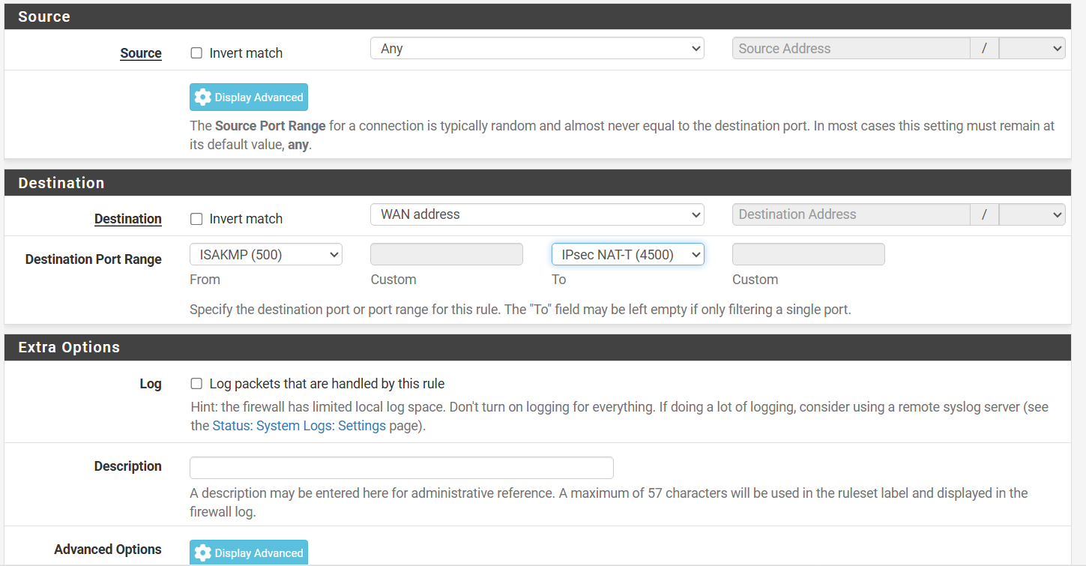
Figure 62: Port Range Assignment: UDP 500 to 4500 — Configuring Destination Port Range from 500 (ISAKMP) to 4500 (NAT-T) into WAN address.
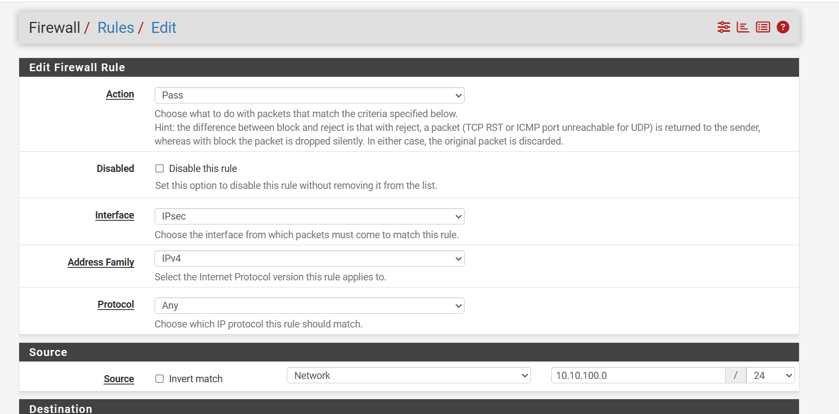
Figure 63: Authorizing Decapsulated IPsec Traffic — Creating pass rule on IPsec interface for source network 10.10.100.0/24 (Mobile Client virtual pool).
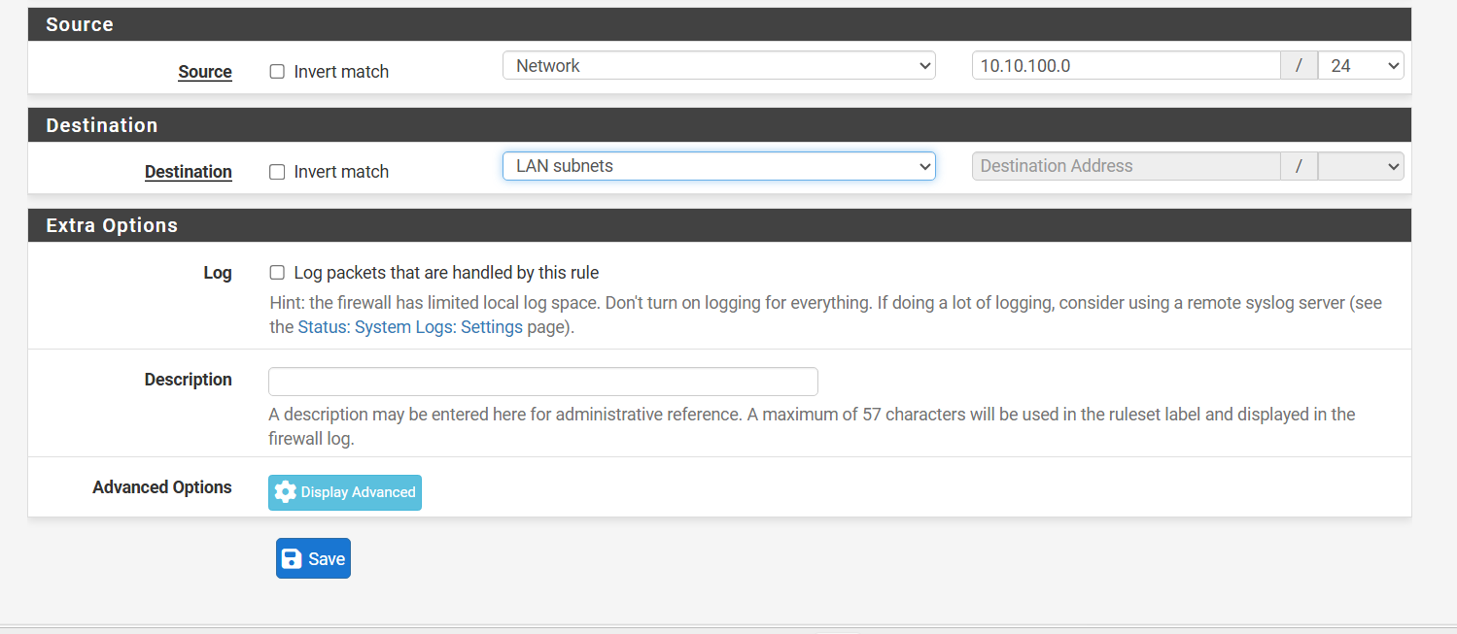
Figure 64: Destination Binding: LAN Subnets — Directing decrypted tunnel traffic into internal LAN subnets (192.168.10.0/24).
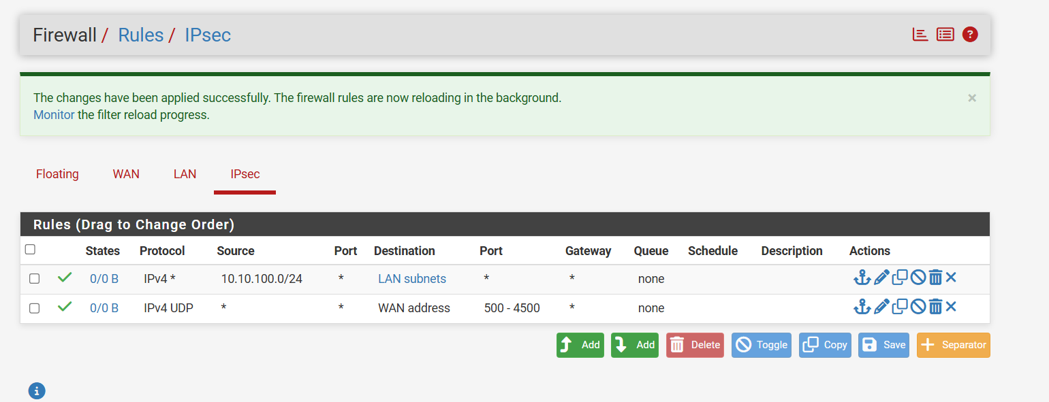
Figure 65: Active IPsec Firewall Rules Table — Firewall / Rules / IPsec showing the active pass rule authorizing 10.10.100.0/24 to traverse internal subnets.

Chapter 6 — Next-Generation Zero-Trust Remote Access: Tailscale Mesh Subnet Router
While traditional IPsec IKEv2 VPNs remain widespread, modern enterprise IT is increasingly migrating toward Zero-Trust Network Access (ZTNA) and peer-to-peer overlay networks. Traditional VPNs suffer from rigid hub-and-spoke topologies, frequent port-blocking on restrictive networks (e.g., hotel or airport Wi-Fi blocking UDP 500/4500), and complex public IP prerequisites.
Tailscale, built atop the modern WireGuard cryptographic protocol, solves these challenges through automatic NAT traversal (DERP relays), ephemeral cryptographic key exchange, and peer-to-peer mesh connectivity. By deploying Tailscale directly on FW-HQ as a 'Subnet Router', pfSense can securely advertise the entire Active Directory network (192.168.10.0/24) into the private Tailnet. This grants authenticated remote engineers instant, encrypted access to domain controllers and file servers without installing any software on the Windows Server itself.

Section 1 — Deploying the Tailscale Package on pfSense
pfSense provides direct integration via FreeBSD packages. Under System > Package Manager > Available Packages, the administrator searches for 'tailscale'. Package 'pfSense-pkg-Tailscale' (v0.1.10, leveraging core WireGuard v1.98.5) is installed:
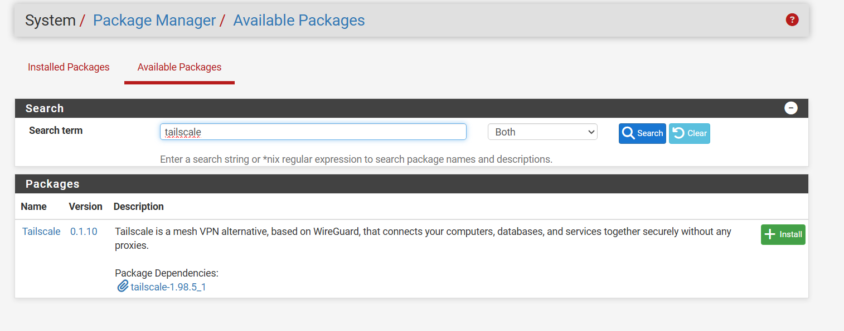
Figure 66: Tailscale Package Selection in pfSense — Locating pfSense-pkg-Tailscale in the official package repository, highlighting its WireGuard mesh capabilities.
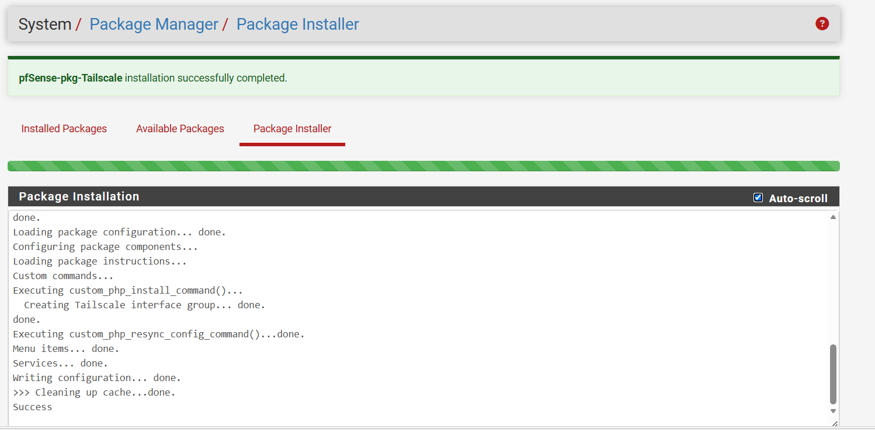
Figure 67: Package Installation Success — Automated installer executing PHP configuration scripts, creating the Tailscale interface group, and committing service entries.

Section 2 — Configuring Tailscale & Subnet Route Advertisement
Once installed, Tailscale configuration is managed under VPN > Tailscale > Settings. The daemon is enabled on standard WireGuard listen port 41641 with persistent state stored at /usr/local/pkg/tailscale/state:
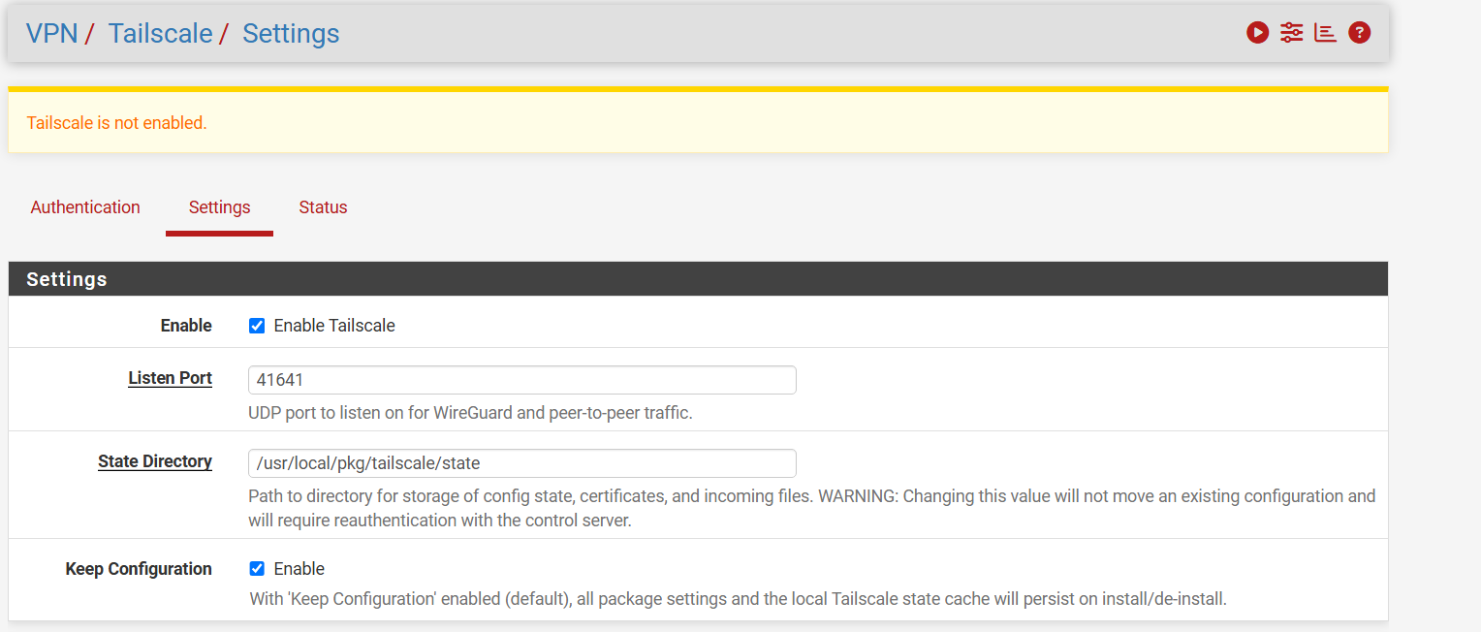
Figure 68: Tailscale General Settings & Daemon State — Enabling the Tailscale service on UDP listen port 41641 with persistent configuration caching.
The critical configuration occurs under Routing: FW-HQ is configured as a Subnet Router by populating 'Advertised Routes' with '192.168.10.0/24' (the Active Directory HQ subnet):
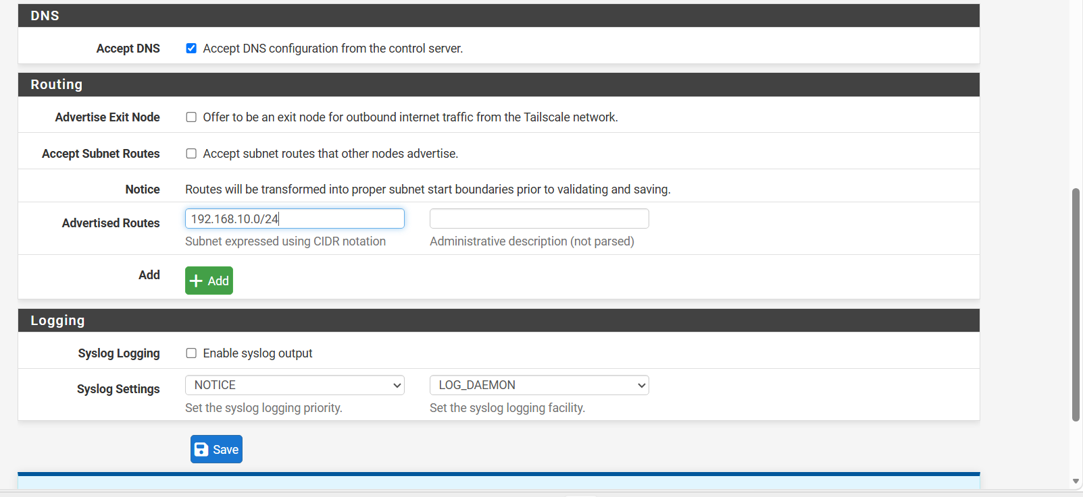
Figure 69: Configuring Advertised Subnet Route (192.168.10.0/24) — Populating Advertised Routes with 192.168.10.0/24 to expose the internal Active Directory LAN to authorized Tailnet peers.

Section 3 — Authenticating the Node via pfSense CLI
To link the firewall to the administrator's Tailnet, terminal access is opened. Executing 'tailscale up --advertise-routes=192.168.10.0/24' initially reports 'backend error: invalid key: API key does not exist' because the node requires authentication. Completing the interactive URL authentication links the node to the cloud control plane:
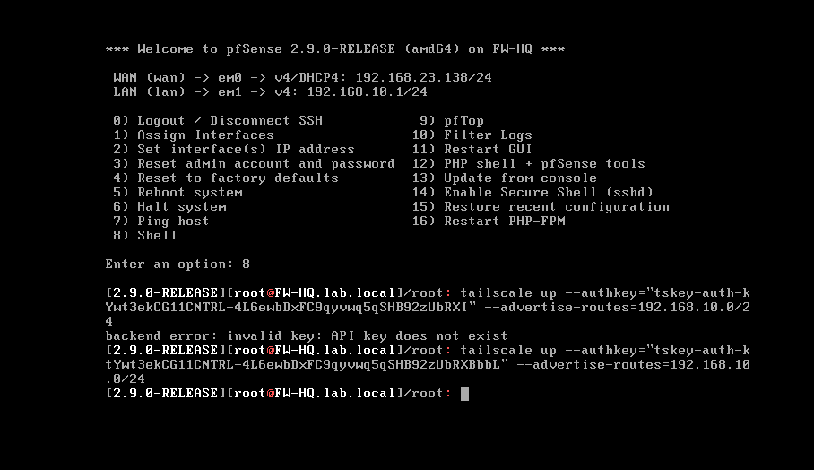
Figure 70: CLI Route Advertisement & Node Activation — Executing 'tailscale up --advertise-routes=192.168.10.0/24' on the pfSense root shell, diagnosing initial auth and completing registration.
Returning to the pfSense WebGUI, VPN > Tailscale > Settings immediately confirms that the node is connected: 'Tailscale is online':
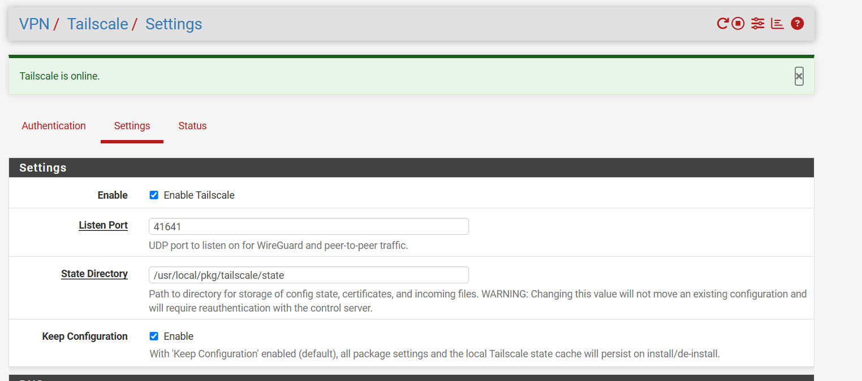
Figure 71: Tailscale Status: Online Confirmation — pfSense GUI reporting healthy daemon state and live registration with the Tailscale coordination server.

Section 4 — Tailscale Admin Console Route Approval
In alignment with Zero-Trust principles, advertising a route from a machine does not automatically grant network access. A Tailscale administrator must explicitly approve the advertised route within the centralized Tailscale Admin Console (login.tailscale.com).
Within the admin console, node 'fw-hq' is visible holding Tailscale IP 100.115.4.8 (FreeBSD 16.0). Under Machine Settings > Edit Route Settings, the administrator reviews and enables route '192.168.10.0/24':
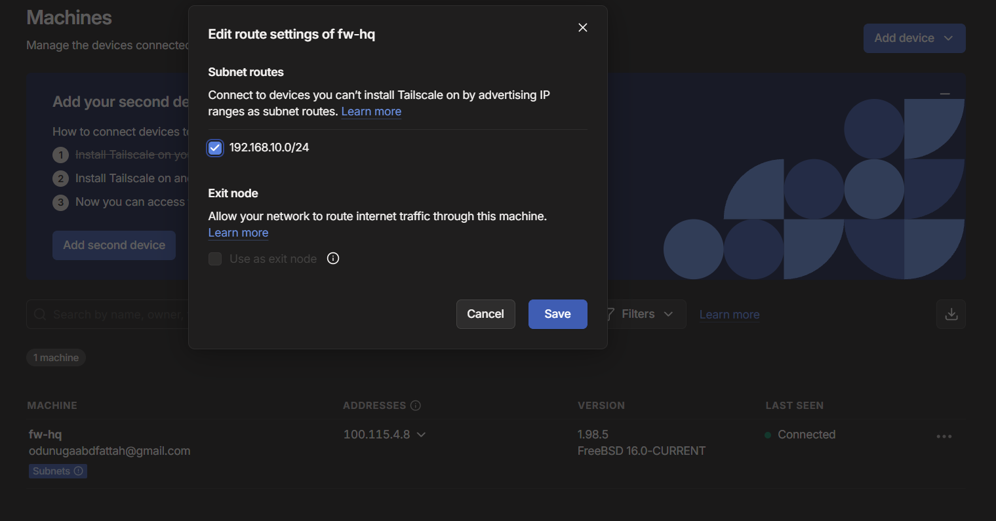
Figure 72: Approving Subnet Route in Tailscale Admin Portal — Authorizing the 192.168.10.0/24 subnet route on node fw-hq (100.115.4.8), empowering authorized tailnet clients to route into the AD LAN.

Section 5 — pfSense Firewall Policy for Tailscale Traffic
When the Tailscale package initializes, pfSense creates a dedicated 'Tailscale' firewall interface tab. An explicit pass rule must be defined to permit incoming overlay traffic to reach the local AD servers:
- Firewall Rule Parameters: Pass | Interface: Tailscale | Address Family: IPv4 | Protocol: Any (or TCP) | Source: Any | Destination: LAN subnets (192.168.10.0/24) | Description: 'Allow Tailscale inbound traffic to AD LAN'.
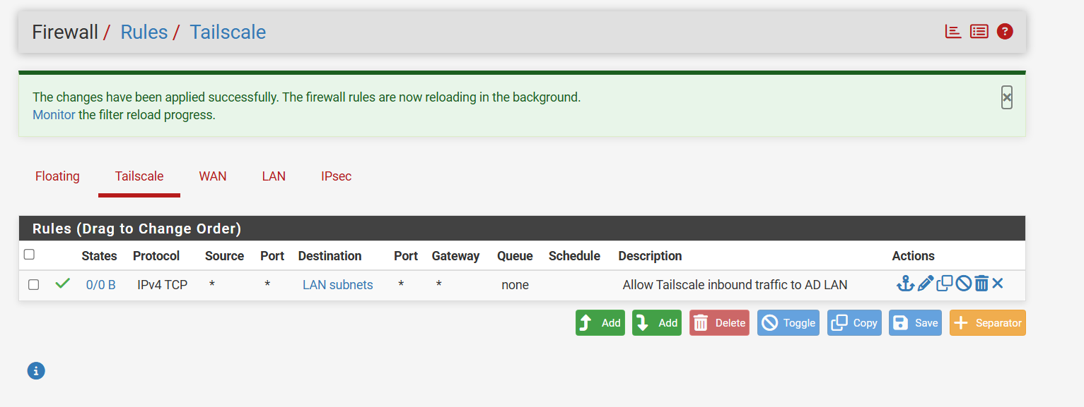
Figure 73: Tailscale Interface Firewall Ruleset — Committing pass rule authorizing inbound Tailscale mesh traffic to freely traverse into internal Active Directory subnets.

Section 6 — External Client Connection & RDP Management Verification
To test real-world remote access, an external Windows workstation (DESKTOP-LBL51L9) residing on an external internet network authenticates into the administrator's Tailnet:
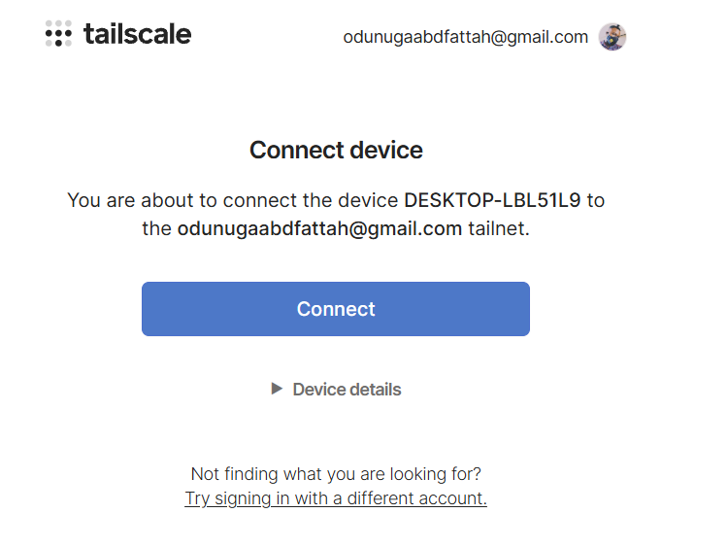
Figure 74: External Client Authentication into Tailnet — Authorizing device DESKTOP-LBL51L9 into the central Tailnet via browser SSO authentication.
On DC01, Remote Desktop is enabled under System Properties > Remote tab by selecting 'Allow remote connections to this computer':
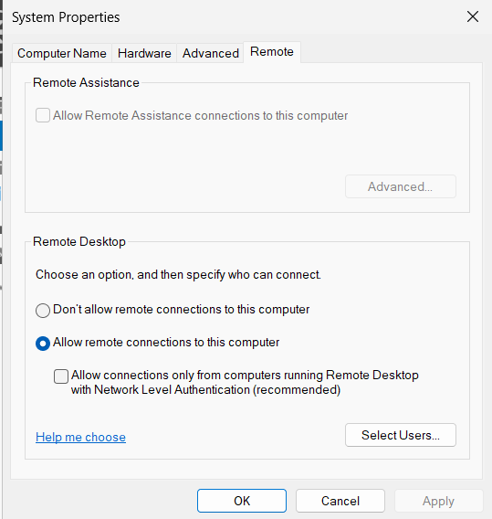
Figure 75: Enabling Remote Desktop on Domain Controller (DC01) — Configuring Windows Server 2025 to accept inbound RDP management connections across authorized administrative interfaces.
From the external workstation, PowerShell is executed to test end-to-end reachability across the overlay. Test-NetConnection verifies TCP Port 3389 reachability against the internal private IP of DC01 (192.168.10.10):
Test-NetConnection -ComputerName 192.168.10.10 -Port 3389

The output is definitive: SourceAddress is 100.106.74.113 (the external PC's Tailscale IP), InterfaceAlias is 'Tailscale', RemoteAddress is 192.168.10.10, and TcpTestSucceeded is **True**! The packets traversed the WireGuard mesh into pfSense, which seamlessly routed them into the physical AD LAN without needing NAT or port forwarding.
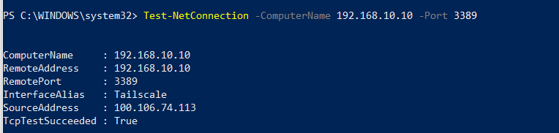
Figure 76: Cross-Subnet RDP Port Verification over Tailscale — PowerShell confirms TcpTestSucceeded: True against 192.168.10.10:3389 from Tailscale source 100.106.74.113, proving end-to-end overlay routing.
Finally, Remote Desktop Connection (mstsc.exe) is launched against 192.168.10.10. The administrator provides domain credentials (Administrator@lab.local) and accepts the internal machine certificate:
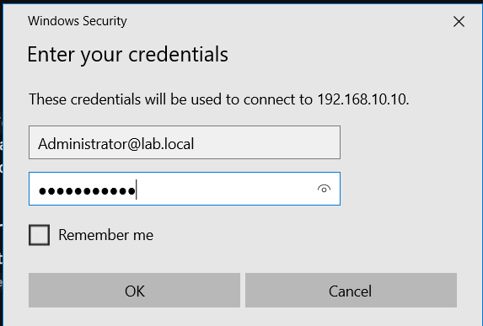
Figure 77: RDP Domain Authentication Prompt — Connecting to 192.168.10.10 over Tailscale using Active Directory domain credentials (Administrator@lab.local).
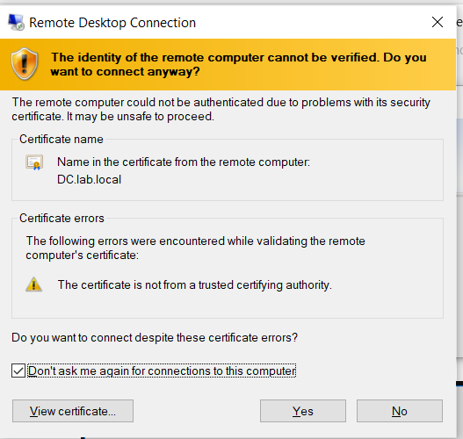
Figure 78: RDP Security Certificate Validation — Validating the host identity of DC.lab.local prior to encrypted desktop session establishment.

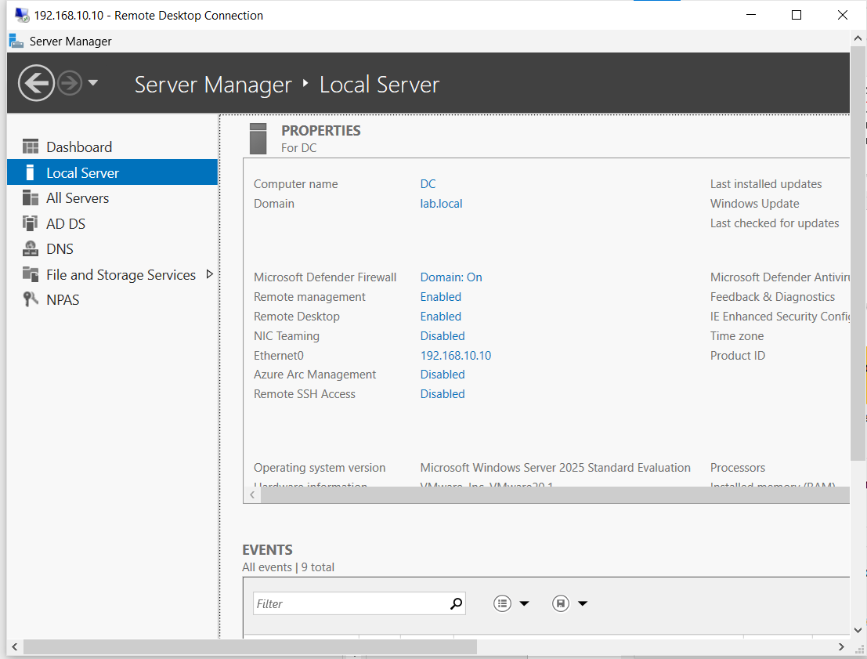
Figure 79: Active Remote Management Session on DC01 — Fully established Windows Server 2025 Server Manager desktop session operating flawlessly across the Tailscale Subnet Router.

Chapter 7 — Endpoint Security, Client Trust & Certificate Store Management
Public Key Infrastructure (PKI) relies fundamentally on trust anchors. When an enterprise operates an internal Certificate Authority (such as the Lab-CA created in pfSense), client operating systems (Windows, macOS, iOS, Android) will inherently reject any certificate issued by that authority until its root certificate is explicitly anchored into the local operating system's Trusted Root Certification Authorities store.
Without this trust anchor, Windows native IKEv2 VPN connections will instantly fail with fatal cryptographic errors (Error 13801: 'IKE authentication credentials are unacceptable'), HTTPS administrative portals will display red security warnings, and internal services will remain unreachable. Chapter 7 documents the endpoint deployment and cryptographic anchoring of the root CA.

Section 1 — Inspecting the Untrusted Certificate State
On the remote client workstation, the exported certificate file 'Lab-CA.crt' resides in the user's Downloads directory. Opening the certificate reveals the default untrusted state: Windows displays a warning badge indicating: 'This CA Root certificate is not trusted. To enable trust, install this certificate in the Trusted Root Certification Authorities store.'

Figure 80: Untrusted Root CA Certificate Warning —
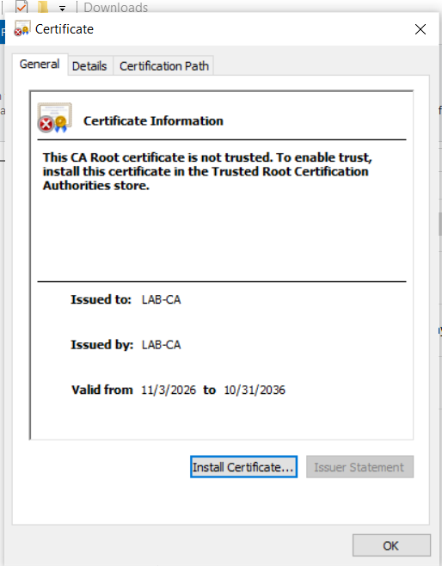
Inspecting Lab-CA.crt in Windows: valid from 11/3/2026 to 10/31/2036, displaying explicit lack of local operating system trust.

Section 2 — Deploying the Root CA via the Certificate Import Wizard
To install the certificate correctly, the administrator clicks 'Install Certificate...', which launches the Windows Certificate Import Wizard. The administrator selects 'Current User' or 'Local Machine' (Local Machine establishes trust for every user on the workstation, which is required for machine-level VPN tunnels).
Crucially, the administrator must NOT accept the default 'Automatically select the certificate store based on the type of certificate'. Automatic selection frequently misplaces root CAs into the 'Intermediate' or 'Personal' stores, leaving the trust chain broken. The administrator must explicitly choose 'Place all certificates in the following store':
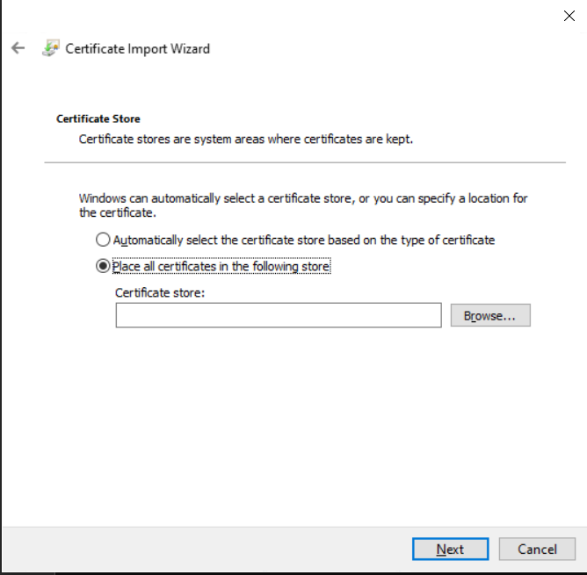
Figure 81: Certificate Store Manual Selection — Overriding automatic store selection to enforce explicit placement into the trusted root hierarchy.
Clicking 'Browse...' opens the Select Certificate Store dialog. The administrator selects 'Trusted Root Certification Authorities' and clicks OK:
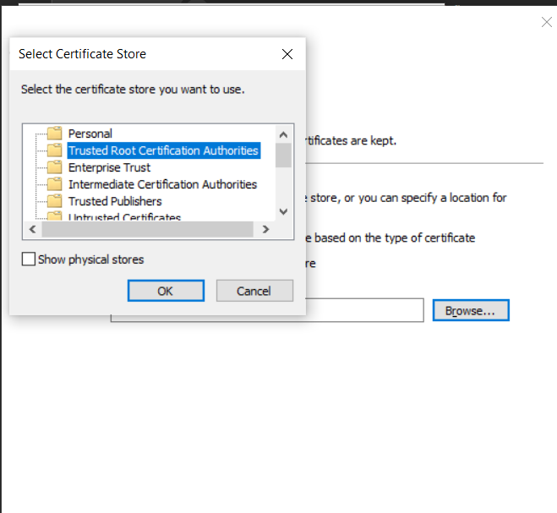
Figure 82: Selecting Trusted Root Certification Authorities — Designating the operating system's root trust store as the destination container for Lab-CA.
The completion screen summarizes the action: Certificate Store Selected by user: Trusted Root Certification Authorities. Upon clicking Finish, Windows commits the certificate to the cryptographic engine. From this moment onward, all certificates signed by Lab-CA (including pfSense's VPN-Server-Cert) are validated seamlessly without warnings or connection aborts:
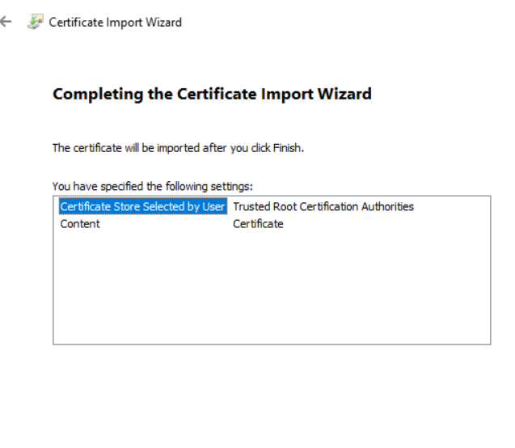
Figure 83: Certificate Import Wizard Finalization — Successful import confirmation, establishing the enterprise cryptographic anchor for IKEv2 VPN and secure management.

Section 3 — Enterprise Automated Certificate Distribution
Enterprise Deployment Vectors: While manual installation is ideal for lab validation and isolated bring-up, enterprise production environments automate root certificate distribution at scale using Group Policy or Mobile Device Management (MDM):
- Active Directory Group Policy (GPO): In an Active Directory domain, the administrator opens gpmc.msc, edits a domain-wide baseline GPO, and navigates to: Computer Configuration > Policies > Windows Settings > Security Settings > Public Key Policies > Trusted Root Certification Authorities. Importing Lab-CA.crt here pushes the certificate automatically to thousands of domain-joined endpoints during background policy refresh.
- Microsoft Intune / MDM: For non-domain-joined, remote, or mobile devices (laptops, iPhones, Android), the CA certificate is packaged into a Trusted Certificate Configuration Profile in Microsoft Intune, deploying automatically upon device enrollment.

Chapter 8 — Comprehensive Troubleshooting Field Guide & Enterprise Takeaways
Systems and network engineering is fundamentally defined not just by how infrastructure is built when everything works, but by the rigor and methodology used to diagnose and resolve failures when components inevitably break. This chapter consolidates the systematic diagnostic methodology and failure modes documented throughout this lab.

Section 1 — The Unified 4-Layer Diagnostic Methodology
Whenever a service, share, tunnel, or logon fails, troubleshooting must proceed methodically from the bottom up. Never troubleshoot an application issue before verifying network reachability and name resolution:
Diagnostic Layer | Core Question to Answer | Primary Diagnostic Tools & Commands | Typical Failure Root Cause
Layer 1: Socket / Transport | Can the client physically and logically reach the server IP and port? | Test-NetConnection -Port <X>  ping <IP>  traceroute / tracert | Firewall rules dropping packets, closed service ports, wrong default gateway, missing routes.
Layer 2: Name Resolution (DNS) | Does the client resolve the exact FQDN to the correct server IP? | nslookup <FQDN>  Get-DnsClientServerAddress  ipconfig /displaydns | Client asking NAT router instead of DC, rogue DNS registration, missing A/MX records, stale cache.
Layer 3: Authentication & AAA | Are the client's credentials accepted by the identity provider? | nps.msc event logs (Security Log)  pfSense Diagnostics > Auth  Test-ComputerSecureChannel | Shared secret mismatch, wrong username format, account disabled, dial-in permission denied, MS-CHAP-v2 mismatch.
Layer 4: Application & Policy | Does the user possess the specific rights on the target resource? | Effective Access tab  gpresult /r /scope user / computer  eM Client Diagnostics | NTFS inheritance leak, user group token not refreshed (logoff required), UNC vs local path misconfiguration.

Section 2 — Master Diagnostic & Failure Resolution Matrix
The following matrix summarizes the real-world gotchas encountered, diagnosed, and resolved during this project:
Symptom / Error State | Technical Root Cause | Step-by-Step Remediation Strategy
Mail stuck in Outbox; domain logons fail intermittently. | Dual-homed VM has both LAN Segment and NAT adapters. NAT adapter owns default gateway; Windows queries NAT DNS for lab.local. | Lower LAN adapter interface metric to 10; raise NAT to 50 via Set-NetIPInterface. Untick 'Register this connection's addresses in DNS' on NAT adapter. Run ipconfig /flushdns.
pfSense WAN ping returns 100% packet loss between sites. | pfSense enforces stateful default-deny on all unsolicited inbound WAN traffic. | Navigate to Firewall > Rules > WAN. Create pass rule for Protocol: ICMP, ICMP Subtype: Echo Request, Destination: WAN address.
RADIUS authentication timeout or Access-Reject from pfSense to DC01. | Shared secret mismatch in NPS RADIUS client, or NPS server not registered in Active Directory. | Verify shared secret matches perfectly on both ends ('Pass123'). Open nps.msc, right-click NPS (Local) > 'Register server in Active Directory'. Check Event Viewer Security Log (Event ID 6273/6272).
Windows IKEv2 VPN fails with Error 13801: 'IKE authentication credentials unacceptable'. | Server certificate lacks external WAN IP in Subject Alternative Name (SAN), or Root CA not installed in Trusted Root store. | Regenerate server certificate with SAN Type: IP Address = 192.168.23.138. Import Lab-CA.crt into client's 'Trusted Root Certification Authorities' store.
Tailscale CLI reports 'backend error: invalid key: API key does not exist'. | Tailscale node initialized without authentication authkey or pending browser login. | Open pfSense console, run 'tailscale up --advertise-routes=192.168.10.0/24', copy authentication URL into browser and sign in. Approve route in Tailscale Admin Console.
Group Policy Wallpaper displays blank / black background on client workstations. | GPO configured with local path ('C:\Wallpaper\Team.jpg') which does not exist on client C: drives. | Store wallpaper in a shared folder (\\DC01\Wallpaper\Team.jpg) with Authenticated Users (Read). Update GPO path to the UNC format.
Edge browser URL Allowlist blocks internal browser pages like edge://policy. | URLBlocklist = * aggressively catches internal browser schemes. | Add 'edge://*' and 'chrome://*' explicitly to the URLAllowlist policy.

Section 3 — Enterprise Hardening & Architectural Next Steps
Production Evolution Roadmap: This project established a comprehensive multi-service lab environment. In transitioning these concepts to production enterprise infrastructure, the following architectural enhancements represent the natural evolution:
- 1. Messaging Segregation: Decommission hMailServer. Deploy dedicated Microsoft Exchange Server clusters or migrate corporate messaging to Microsoft 365 / Exchange Online, leveraging Microsoft Entra Connect (formerly Azure AD Connect) to synchronize on-premises lab.local identities with cloud services.
- 2. High Availability Domain Services: Deploy a secondary Domain Controller (DC02) to establish Active Directory replication, eliminate single points of failure, and distribute FSMO (Flexible Single Master Operations) roles.
- 3. Enterprise PKI Tiering: Transition from standalone pfSense CA to a formal two-tier Active Directory Certificate Services (AD CS) hierarchy: an offline Root CA paired with an online Enterprise Subordinate Issuing CA integrated with Group Policy auto-enrollment.
- 4. 802.1X Network Access Control (NAC): Deploy IEEE 802.1X Network Access Control on physical access switches and enterprise Wi-Fi access points, leveraging the newly provisioned NPS RADIUS infrastructure for dynamic VLAN assignment and certificate-based device authentication (EAP-TLS).
- 5. Centralized SIEM & Telemetry: Integrate pfSense Syslog and Windows Server Security Event Logs into a centralized Security Information and Event Management (SIEM) platform (e.g., Wazuh, Splunk, or Microsoft Sentinel) to monitor unauthorized access attempts, failed Kerberos logons, and perimeter port scans.
- DHCP

